Distributing the cycle pressure on the transport network:
Influence of route advice on route choice behaviour of cyclists.

Bachelor thesis of Hozan Rashid
Student number: S2767627
Supervisor: Menno Rol
Second Assessor: Ben Bewersdorf
Bachelor of Liberal Arts and Sciences
Faculty of University College Groningen
University of Groningen
Groningen, the Netherlands
January 2018

Abstract
This study investigates how the cycle pressure on a transport network can be distributed by advising cyclists certain routes. This will be done by evaluating a project named ‘Smart Bicycle Routes’ set up by the municipality of Groningen in the Netherlands. The project aims to distribute the amount of student cyclists to the university campus ‘Zernike’ over multiple routes to avoid dangerous situations and traffic delay caused by an overload of cyclists on one route. The project promoted multiple advised routes to Zernike by using signs on the road and ground surface to guide students. A mixed methods approach was used to carry out the research. An online survey was conducted to map the route choice behaviour of the student cyclists. The results were further analyzed and explained by performing interviews. The project promoted alternative routes and optimized the comfort of each route to minimize quality differences between the routes such as surface quality. Additionally, known by the municipality or not, there was no significant differences in perceived travel time among the different route options. Lastly, intended by the municipality or not, the routes each had significantly different characteristics that made each route equally attractive. It was the combination of those factors that made the project successful. In conclusion, for an evenly spread amount of cyclists over different route options for the same destination the routes need to be perceived as having no significant differences in travel time or any other factor that could influence route choice such as surface quality but one significantly different factor for each distinctive route option such as greenery/scenery, convenience such as passing by a shopping centre, most direct route. Further research is needed on the factors making up the personal preferences of route choice and its impact on route choice behaviour.

Table of Contents

Chapter
- INTRODUCTION………………………………………………………………...5
Topic………………………………………………………………………5
Casus: Smart Bicycle Routes……………………………………………...5
Research…………………………………………………………………...7
- REVIEW OF LITERATURE…………………………………………………..…8
Route choice behaviour………………………………………………........8
Influence of municipal policies in the Netherlands…………………….....8
- METHODOLOGY………………………………………………………..………9
Mixed methods……………………………………………………..……...9
The survey………………………………………………………………..10
Interviews………………………………………………………………...13
- RESULTS………………………………………………………………………..16
Results online survey………………………………………………….....16
Results Interview………………………………………………………...21
- DISCUSSION……………………………………………………………………26
- CONCLUSION………………………………………………………………......30
Evaluation project ‘Smart Bicycle Routes’………………………………30
Overall conclusion……………………………………………………….31

REFERENCES

List of Tables
1 Results route choice 17
2 Route choice: respondents living in the east of Groningen 18
3 Route choice: respondents living in the west of Groningen 19
4 Results survey question 3 20
5 Interview results route motivation 23/24

List of Figures
1 Residence respondents 11
2 Route options Zernike 12
3 Motivation route choice 12
4 Optional question survey 13
5 Illustration routes of the ‘Smart Bicycle Routes’ 15
6 Circle diagram route choice 18
7 Macro-micro-macro model....................................................................................27

Introduction

Topic
Within Europe the Netherlands is the country with the highest rate of cyclists in traffic, with the city of Groningen on top due to the presence of two universities and young demographic population (Rietveld & Daniel, 2004, 542). From 1990-2010 the popularity of cycling increased in the Netherlands due to the implementation of bicycle-friendly policies, resulting in more cyclists and therefore a higher demand of an efficient and safe cycle network in cities (Rietveld & Daniel, 2004, 537). Absence of an efficient and safe transport network would lead to dangerous situations on the road and traffic congestion resulting in societal economic costs (Arnott & Small, 1994; Elvik, 1994). A good understanding of route choice behaviour is crucial to the success of a transport network since cyclists usually have more than one route option to their destination (Bovy & Stern, 2012).
In the city Groningen the increased amount of student cyclists travelling to the university campus ‘Zernike’ also resulted in problems (De Jager, 2017, 15). To avoid too many cyclists on one route, the municipality designed a project called ‘Smart Bicycle Routes’. This project created multiple routes to Zernike with the aim of a well spread cycle pressure on the network (Gemeente Groningen, 2017a). This thesis will evaluate to what extent cyclists in the Netherlands can be redirected when they are being provided with advised routes. In order to answer this question the project ‘Smart Bicycle Routes’ will be used as a casus.
Casus: Smart Bicycle Routes
In 2016 the University of Groningen and Applied University ‘Hanze’ registered a number of approximately 57 000 students combined (Rijksuniversiteit Groningen, 2017; Hanze Hogeschool, 2017). Most of the classes and exams are being held at the ‘Zernike Campus’ located in the north of the city Groningen. Students from all over the city travel to ‘Zernike Campus’ each day with the most popular form of transportation being a bicycle (De Rook, 2015). In 2016, around 31 677 students travelled to Zernike by bike (De Jager, 2017, 45). This number of cyclists in Groningen travelling to same destination resulted in disruptions of other traffic causing dangerous situations and societal economic costs. Cyclists using the route via Zonnelaan have priority over the cars coming in and out the ring road in Groningen. The high number of cyclists resulted in traffic delays and dangerous situations due to drivers becoming impatient (De Jager, 2017, 14 &15).
In 2013 the municipality of Groningen came up with a project named ‘Smart Bicycle Routes’. The project aims to create attractive routes to Zernike Campus based on comfort, speed and safety to stimulate cyclists to use certain lanes and spread the cycle pressure on the network. The goal of the project was to spread the cyclists over multiple routes by promoting alternative routes to Zernike (Gemeente Groningen, 2017b). These routes were promoted during the introduction fairs of students and posters in universities buildings and on the street. Routes were marked on the ground and signs were put up to guide the cyclists to Zernike. All routes were improved as much as possible by improving surface quality and traffic situation to optimize comfort and capacity of the routes. The overall aim was to create safe, comfortable, and fast routes to Zernike and eventually create a better cycle network in the city.
The municipality designed two different routes to Zernike namely ‘Route East’ and ‘Route West’, respectively guiding the cyclists from the eastern part of the city and the western part of the city. ‘Route East’ consists of two routes that eventually merge together. One of them is through the Eikenlaan and the other through Kerklaan which at some point merge together and continue through park Selwerd. ‘Route West’ involves the entire Jaagpad. However, both the east and west routes combined do not have enough capacity to for all of the cyclists travelling to Zernike. This means that both routes should be used in addition to the Zonnelaan. Since only a portion of the cyclists using the Zonnelaan need to be stimulated to take other routes, the Zonnelaan or any other possible routes are neither actively encouraged nor discouraged (De Jager, 2017, 17).
Plans to extend ‘Route West’ up and till the Central Train Station of Groningen are currently developed and planned to be executed end 2017. The extension of ‘Route West’ is the last part of the project. Subsequently, the route will be promoted to the new incoming students in September 2018 (Gemeente Groningen, 2017b).
Research
As mentioned before, this thesis will investigate to what extent cyclists in the Netherlands can be redirected when being provided with advised routes. In order to answer this, a process evaluation will be done on the project ‘Smart Bicycle Routes’ of the municipality of Groningen by investigating the route choice behaviour of the student cyclists travelling to Zernike. In order to evaluate this case, the following question needs to be answered: To what extent are cyclists travelling to Zernike redirected due to the project ‘Smart Bicycle Routes’? In other words: What is the influence of the project ‘Smart Bicycle Routes’ on the route choice behaviour of the cyclists travelling to Zernike? To answer this, the route choice behaviour of the cyclists need to be analyzed by investigating which route the student cyclists take to Zernike and why students take that route. With the help of existing literature the influence of the project ‘Smart Bicycle Route’ on the route choice behaviour of the cyclists can be investigated.

Literature review
Route choice behaviour
Research by Golledge (1997) showed how route choice decisions of car drivers within a transport network are based on existing knowledge and experience within that network. Knowledge and experience within a transport network results in a mental map that shape the evaluation of choice alternatives. Even though home-to-work commute seems to be fixed due to the fixed locations of the both destinations, changes in route choice behaviour occur due to exploring new routes to shorten travel time, change of driver or minor changes due to convenience (Papinski, Scott and Doherty, 2009, 355). According to Bonsall (1992) participants are less likely to deviate from the advised route if they are in unfamiliar areas. Bonsall also revealed that typically only a small portion of journeys are made in total compliance with advice. It turned out that compliance with advised routes depends on the knowledge of the driver on the area and the quality of former advised routes. More familiarity on the area increases the confidence of the driver in their ability to find a personally better route. The quality of former received advised routes influences the perceived credibility of other advised routes.
Influence of municipal policies in the Netherlands
Rietveld and Daniel (2004, 10) researched the determinants of bicycle use and the influence of municipal policies. The study used the data of the Bicyclists’ Association in the Netherlands to study the variations in the generalized costs of cycling per municipality. These generalized costs consists of all the costs relating to bicycle use such as travel time and monetary costs but also the costs of the risk of injury and physical costs needed to ride a bicycle. It turned out that these costs depend on the infrastructure and hindrances of the cyclists compared to other road users. These hindrances could be the number of stops for cyclists per unit of distance, proportion of time spent walking or biking slowly, and the obligation to give priority to other road users.

Methodology
Mixed methods
This research involved a mixed methodology. In particular an explanatory sequential mixed method was used. The research consisted of a survey to measure the route choice behaviour of the population combined with interviews afterwards to identify the factors that influenced this choice. First quantitative research was performed by an online survey. The results were analyzed and explained in more detail with qualitative research. Only a quantitative research would not be sufficient to measure the importance of personal preferences on the route choice since the factors making up the personal preferences cannot be predetermined. Additionally, only performing qualitative research would not adequately represent the route choices of the population due to the low number of interviewees. Interviews were held to perform a deeper and more adequate analysis on the motivations of the route choice results of the survey. This approach was chosen to collect a more detailed view of the respondents on their route choice to help explain the results of the survey. Since one database is needed to explain to the other, the best research design is a mixed method methodology (Creswell, 2013, 14). The quantitative data results are thus explained by the qualitative data.
The reason to do the survey first is due to the limitations of stated preferences. Research by Papinski, Scott & Doherty (2009), showed how 44% of the total trips of 31 Canadian car drivers deviated from their planned routes. Deviations of planned routes were attributed to several factors such as opportunistic driving in familiar areas for a personally better route, change of drivers or schedule, and convenience. This means that the route car drivers claim to take was not always the same route they would actually take. Because of the limitations of stated preferences, it is better to first figure out which route the students took to Zernike and subsequently ask them to extensively motivate their route choice during the interviews. By doing the interviews afterwards, the questions of the interviews could be adapted in such a way to gain the information needed understand the results of the survey.
The quantitative part consisted of an online survey displaying the route options to Zernike and an open-question to leave behind a small motivation for their route choice. The survey was taken by students of the RUG or Hanze Hogeschool. In order to evaluate the use of the ‘Smart Bicycle Route’ the route choice behaviour of ‘experienced’ cyclists needed to examined. The meaning ‘experienced’ in this context were people that cycled in Groningen often enough to have sufficient knowledge and experience to have a mental map that can adequately evaluate the different route options. This research will therefore only evaluate the route choice decisions of student cyclists of the RUG or Hanze Hogeschool that live in Groningen for at least one year. Cyclists that recently moved to Groningen may not have this mental map, making it harder to evaluate their route decisions since they do not have the knowledge and experience to evaluate all route options. If the respondents were willing to be interviewed, they could indicate this by leaving their email address behind in the last part of the survey. Among them a random selection was made to be interviewed.
The survey
According to Schonlau, Ronald, and Ellioit (2002), an online survey is the most preferable way to conduct quantitative research that can be conducted with a convenience sample. That way the survey can attract a large number of respondents if the survey is distributed well. Other methods to conduct this survey, such as asking people face-to-face at certain places, would take more time and energy and result in a lower number of respondents. The online survey was programmed on survio.com. The survey could be opened with a link and started with a small description of the research explaining the use of the survey and the people who this survey was meant for. The survey is intentionally designed to be as simple, easy and short as possible to attract sufficient respondents yet still acquire all the information needed.
The survey was opened at the 19th of October until the 28th of October 2017. The best way to reach participants turned out to be through Facebook by sharing the survey link on my personal page and in Facebook groups of study-and sport associations in Groningen. This way people were more personally addressed since they could find a link with the survey and me namely a friend or fellow member of a study- and sport association. Additionally, Facebook friends of mine shared the post on their Facebook wall too. Another effective way to reach out to potential respondents was by using Whatsapp groups of study- sport- and student associations containing a large number of students in Groningen.
Question 1:
As shown in figure 1 the first question was ‘Which area in Groningen do you live?’ This question would determine whether the respondent lives in the east or west or Groningen. The areas indicate a line that show the division of the east and west part of the city.
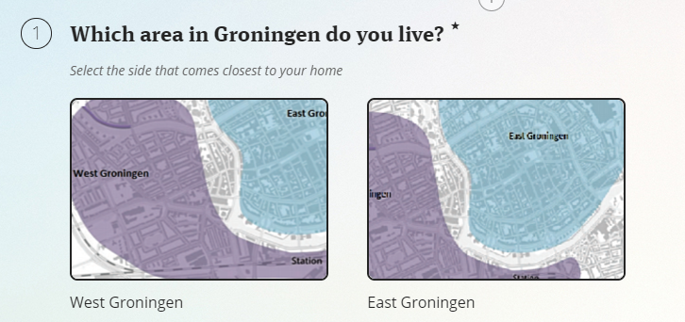
Figure 1: Residence respondents
Question 2:
As illustrated in figure 2, the second question gave six route options by bike to Zernike. Respondents could select the route that matches the most with the route they take to Zernike. Route 1 is the ‘Route West’ of the project Smart Bicycle Route since it goes over the whole Jaagpad. Route 2 goes through Prinsesseweg-Zonnelaan and is not a route within the project of the Smart Bicycle Route. Route 3 is part of ‘Route East’ within the Smart Bicycle Route project. The same applies to route 4. Both route 3 and 4 eventually merge together to the direction of Park Selwerd. Route 5 is not part of the project. Lastly, when a respondent does not take a route that matches with the given routes at all, an option was given to indicate that they take an alternative route.
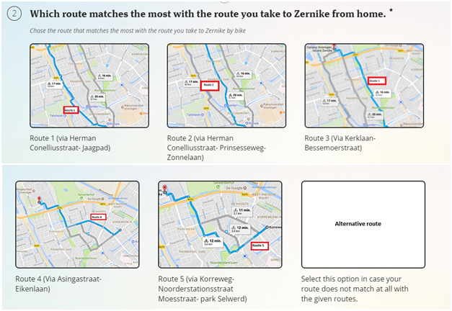Figure 2: Route options to Zernike
Question 3:
As shown in figure 3, the third question is an open question for respondents to explain their route choice. The reason to include an open question was to gain a general set of factors that influenced the route choice of the respondents. This information could be helpful to create more focused interview questions.
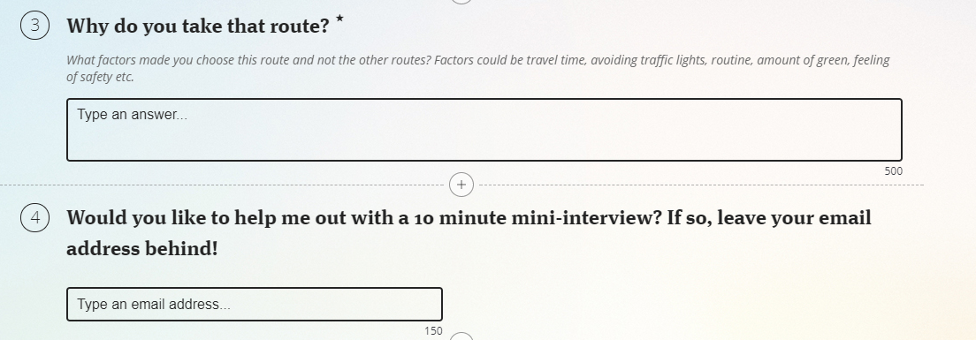Figure 3: Motivation route choice
Question 4:
Lastly, as illustrated in figure 4 respondents could indicate whether they wanted to be interviewed for this research.
Figure 4: Optional question survey
Interviews
Interviews were held to elaborate deeper on the route decisions of the student cyclists to Zernike Campus in order to explore and make sense of the qualitative findings. In total only six students were interviewed due to the extensive analyzing of the comments and limited time.
The interview was semi-structured, face-to-face, one-on-one in-person interviews. The interviews were recorded and subsequently transcribed. The analysis of the interview was performed by the following steps inspired by the data analysis steps for qualitative research designed by Creswell (2013,197).
1: Transform raw data (the recordings) into data for the analysis. This involves the transcribing the recordings.
2: Read through all data to get a general sense of the information
3: Coding by the eight steps of Tesch (1990).
4: Use the coding to generate a description of the people and themes for analysis
5: Interpretation of the meaning of the themes that emerged in step 4.

Interview questions
Part 1:
- Do you live in east or west of Groningen based on the division made on the picture used in the survey.
Part 2: Motivations route choice
- Which route do you take to Zernike?
- Why do you take that route? Explain in detail.
- In which case would you take another route?
For example: different route on specific times such as rush hour, or day and night, or winter with snow
Part 3: Smart Bicycle Route
- Do you know about the ‘Smart Bicycle Route’
-If so: What do you think about that project?
What do you think of those routes?
Why do you (not) you take one of those routes?
-If not *: Would you consider taking one of those routes now?
Why (not)?
- Explanation of ‘Smart Bicycle Routes’ = ‘Smart Bicycle Routes’ is a project of the municipality Groningen. This project involves the creation of attractive routes to Zernike Campus. The routes are promoted to be comfortable, safe en fast routes to Zernike Campus. Figure 5 was shown as an illustration or more clarification on the routes.
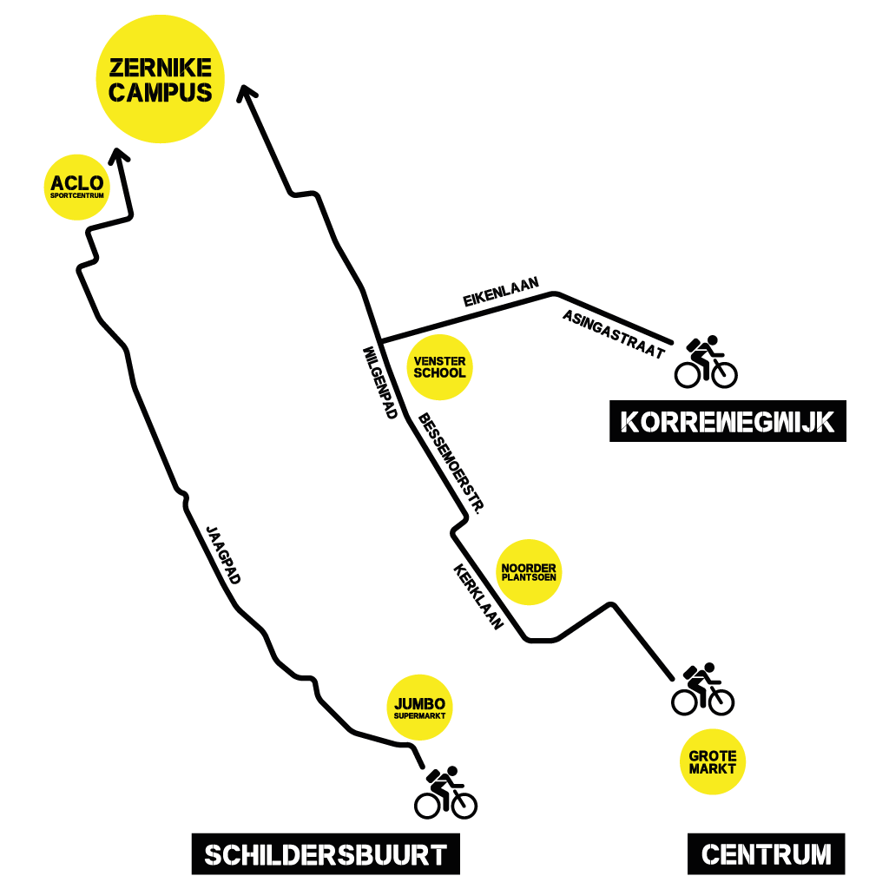
Figure 5: Illustration routes of the ‘Smart Bicycle Routes’

Results

Results online survey
Response online survey
The total amount of respondents was 74. However, the first two responses were mock respondents to test the survey. Respondent number 7 is also made invalid due to the fact that the person told me that he/she does not actually live in Groningen. In total the amount of valid responses are 71. The results will continue with the data of those 71 respondents.
Living in east or west of Groningen
The first question ‘Which area in Groningen do you live?’ could have been answered with two options: east or west. Respondents could determine the area by looking at the images that indicated the east and west side of Groningen. Almost half of the respondents were living in east and the other half in the west side of Groningen. Out of 71 respondents 38 (53.5%) indicated to live in the east of Groningen and 33 people (46.5%) in the west.
Results of respondents in total
Table 1 shows the results of question 2 ‘Which route matches the most with the route you take to Zernike from home?’ Altogether the 71 respondents indicated route 2 and 4 as the most attractive route to Zernike. Route 1 and route 3 followed up and route 5 turned out to be the least attractive route. Only five respondents indicated that they take a completely different route than the route options that were given. Since only 7% of the total respondents indicated this, it is safe to say that the route options that were given presented a valid set of reasonable options to get to Zernike. Figure 6 illustrated the selection distribution of the respondents on the given routes option.

Results route choice
Answer choices | Responses | Ratio
Route 1 (via Herman Conelliusstraat – Jaagpad) | 12 | 16.9%
Route 2 (via Herman Conelliusstraat- Prinsseseweg- Zonnelaan) | 19 | 26.8%
Route 3 (via Kerklaan – Bessemoerstraat) | 12 | 16.9%
Route 4 (Via Asingastraat- Eikenlaan) | 19 | 26.8%
Route 5 (via Korreweg-Noorderstationsstraat-Moesstraat-Park Selwerd) | 4 | 5.6%
Alternative route (Select this route in case your route does not match at all with the given routes) | 5 | 7%
Table 1: Results route choice

Figure 6: Circle diagram route choices
Route choice in the east of Groningen
As shown in table 2, route 4 is by far the most attractive route from the east. The second most popular route turned out to be route 3. Both of these routes are the categorized as the ‘Smart Bicycle Route’. Only one third of the total respondents that lived in the east take another route.
Route choice respondents living in the east of Groningen
Route 1 | Route 2 | Route 3 | Route 4 | Route 5 | Route 6
1 (2.6%) | 5 (13.2%) | 7 (18.4%) | 19 (50%) | 3 (7.9%) | 3 (7.9%)
Table 2: Route choice: respondents living in the east of Groningen
Route choice in the west of Groningen
As seen in table 3 most of the respondents that lived in the west of Groningen take route 2 followed by route 1. Route 2 was chosen by 42.4% of the respondents that lived in the west and route 1 by 33.3%. Together route 1 and 2 were chosen by 75.7% of the respondents. There is no striking difference between them. The alternative route of ‘Route West’, route 2, turns out to be a strong if not stronger competitor of the routes taken to Zernike from the west. Again, 75.7% of the respondents from the west take either route 1 or route 2.Only 6.1% indicated to take a completely different route than the routes that were given. Route 4 was selected by one from the west. There are noticeable differences in the route choices of people living in the east and west.
Route choice respondents living in the west of Groningen
Route 1 | Route 2 | Route 3 | Route 4 | Route 5 | Route 6
11 (33.3%) | 14 (42.4%) | 5 (15.2%) | 0 (0%) | 1 (3%) | 2 (6.1%)
Table 3: Route choice: respondents living in the west of Groningen
Results factors underlying route choice
Lastly, respondents were asked to write down the factors that made them choose this route. The answers were analyzed and grouped into 6 categories:
- Avoiding traffic (lights) and directness of the route
- Green/nature and scenery
- Minimization of travel time
- Space/room to cycle
- Routine
- Convenience of the route choice such as the presence of a supermarket on the way or a bus stop.
Minimization travel time and avoiding traffic (lights) are two separate factors since the route with the least amount of travel time does not automatically involve the least of amount of traffic lights. People can prioritize one over another. Fastest and shortest are interpreted the same way, namely to minimize travel time.
Eventually the number of times the respondents mentioned one of these factors are represented in the table below. If a respondent mentioned the same factor more than once, it is still counted for 1. The results are shown in table 4.

Factors underlying route choice
ROUTE | Avoiding traffic (lights) + directness lane | Green, nature, scenery | Minimization travel time | Space/room to cycle | Routine | Convenience (Supermarket on the route, easy to remember, bus stop on the route in cause of bicycle troubles)
1 (13) | 10 | 5 | 3 | 3 | 0 | 0
2 (18) | 8 | 1 | 13 | 0 | 3 | 1
3 (12) | 7 | 1 | 8 | 0 | 2 | 3
4 (19) | 8 | 1 | 16 | 0 | 1 | 2
5 (4) | 0 | 0 | 3 | 0 | 0 | 1
6 (5) | 1 | 0 | 3 | 0 | 0 | 1
Total | 34 | 8 | 46 | 3 | 6 | 8
Table 4: Results survey of question 3
Coming from east and west could only influence the route chosen to Zernike, as we have seen in the results before, but not the factors why they choose that route. Therefore, no distinction is made here between living in the east or west
Outcome
The factors underlying the choice for route 1 was the absence of traffic (lights). Additionally, the greenery and scenery of route 1 turned out to be a meaningful factor. However, no one mentioned route 1 to be convenient or a routine. Route 2 is mostly chosen due to its shortest travel time. Respondents still mentioned the avoidance of traffic lights but it was not the most important factor. People taking route 2 choose the minimization of travel time above the absence of traffic lights. Route 3 turned out to be chosen mostly because of its low travel time and also the avoidance of traffic lights. Route 4 is also mostly chosen because of its low travel time and avoidance of traffic lights. Routes 5 and 6 have such a small amount of respondents that their results cannot indicate much.
Even though the importance of the factors between the routes cannot be explained, the amount of times the factor was mentioned in total can be compared. It is safe to say that the minimization of travel time is the most important factor for the respondents.
All in all, the respondents turned out to value travel time minimization the most. This is followed by the avoidance of traffic lights. From the east route 4 is the route that provides these values the most compared to the other routes. Based on the factors of minimization of travel time and avoidance of traffic lights, route 2 is indicated as the most attractive from the west. From the west, route 2 is perceived as the route with the shortest travel time despite the fact that route 1 has fewer traffic lights. Since travel time is higher valued than the absence of traffic lights route 2 is the most attractive route from the west.

Results Interviews
General
The last question on the survey was an option to leave an email address behind to be interviewed. This was done by 16 people. Six of them were interviewed and were selected based on their availability within a certain time period. Interviews lasted on average 3 minutes. Longer interviews were expected but people were very clear about the reasons for their route choice. However, the interviews did turn out to be helpful in explaining the results of the survey. During the interview the subject could not only explain why they take their route but also why do not take the other route options. The subjects had the chance to elaborate more on their route choice t and explain why they do not take another route. They could also explain in which situation they would consider another route. This is all valuable information that could not have been gathered by only the survey despite the open question.
The subjects were coded in the following way:
Number of subject – Living the East (E) or West (W) of Groningen – Male (M) or Female (F).

Motivations route choice
Five themes have emerged from the motivations for the route choice of the subjects.
- Travel time turned out to be the main reason for a route choice. This is in line with the results of the survey. In almost every interview travel time was mentioned as the first factor for their route choice.
- Traffic lights seemed to be the second most important factor in route choice, which is also in line with the results of the online survey.
- Remoteness of the route consisting of comments such as isolation and the absence of other people or buildings.
- Occupation rate of the route turned out to be a factor during the interviews. This theme consists of comments regarding the occupation of the route by other cyclists.
- Scenery of the route
Table 5 shows the factors motivating the route choice with the relating comments of the subjects.

Motivation route choice
Subject Code | Route Choice | Travel Time | Traffic Lights | Remoteness Route | Occupation Rate of Route | Scenery Route
1-E-M | Jaagpad | “It is the fastest one. The shortest one for me” | “I hate traffic lights.” | “I like to be in an isolated place” |  | “The route is through a really nice park”
2-W-F | Prinsesseweg-Zonnelaan | “Cause it is the shortest route I think” | “There are two traffic lights on my way so that is oke. However, if it would be more, I would take another route”.
3-E-F | Eikenlaan |  |  |  | “It is less crowded on my route than on the Noorderplatsoen. That route is way more crowded so I skip that one.”
4-W-F | Jaagpad | “It is the fastest one for me”. | “I also like the fact that I can cycle non-stop. The traffic lights are indeed a factor for me”. | “That route (Jaagpad) is not well lighted at night and I feel less safe there (…) It is relatively remote”. | “I like it when the route I take is not crowded” | “It is the prettiest route”
5-W-F | Prinsesseweg-Zonnelaan | “Zonnelaan is the fastest” | “At night the traffic lights are orange so I can usually just go straight. It is superchill if you are on the intersection and don’t have to wait too long.
6-W-F | Prinsesseweg- Zonnelaan |  | “I like the traffic lights. Makes me feel safe”. | “The Jaagpad is scary. It makes me think of a forest route”.
Table 5: Interview results route motivations
The route on the Jaagpad got some contrasting comments. The route was described as the prettiest route and its greenery was attractive for the cyclists, however the interviews also revealed that some subjects (4-W-F and 6-W-F) described the route as scary and remote.
Additionally, it is also remarkable how almost everyone strongly disliked the presence of traffic lights on their route except for subject 6-W-F. The presence of traffic lights gave the subject the feeling of safety while most others associated traffic lights with annoyance and waiting times.
Willingness to change routes
Most, 5 out of 6, of the subjects clearly indicated not to switch routes in any situation. This was seen during the interviews on the question: “In which case would you take another route?” with comments such as:
Subject 1-E-M: “I stick to my own route”
Subject 5-W-F: “I would definitely not switch”
Subject 3-E-F: “I stick to my own route”
Subject 6-W-F: “No (...) The route I take now feels familiar”
Subject 2-W-F: “I am stubborn and take my own route”
However, both subject 4 and 5 indicated to take another route at night.
Subject 4-W-F: “I do take another route when I come from the city at night. Then I go through the city [Zonnelaan]. That cycle route [Jaagpad] is not very well lighted at night I feel less safe there. Partly due to the fact that is not lighted that well but also because it is relatively remote. (…) At night it decreases the feeling of being safe, making you feel that something bad could happen”. Subject 6-W-F also perceived the Jaagpad as scary.
Subject 5-W-F also changed route late at night: “No I would definitely not switch. There is, however, this neighbourhood you have to go through. That neighbourhood is quite sketchy since it always smells to weed. I would not consider it chill to cycle there on my own at 3 o’clock in the morning. In any other case, I would not really take another route”.
Distrust Smart Bicycle Route
Lastly, one subject also mentioned the distrust of the travel advice of the Smart bicycle route. The subject (2-W-F) said the following: “I think they are trying to prevent students from taking a route that interferes with cars. I think it wants me to take the Jaagpad but that is not really chill. They can’t trick me going there. I am stubborn and I take my own route”. This subject doubts the quality of the advised route by describing the advice as a trick implying that the advice was not in the interest of this person
Reduction anxiety and stress
One subject mentioned that the signs on the road helped him to find his way when he got to Groningen for the first time.
1-E-M: “ I arrived here on year ago. I saw it and I thought it was super convenient because I got lost all the time. I saw the road was giving me directions. It was perfect for me to see a sign. I think it is a really good idea.”

Discussion
In the online survey travel time turned out to be a factor in deciding a route. This is in accordance with the research of Papinski, Scott, and Doherty (2009b) where 31 Canadian drivers indicated travel minimization to be the most important factor in deciding their route choice. Both the drivers in the former research and the cyclists in this research mention the avoidance of traffic lights as the second most important factor of route choice. Even though the research of Papinski, Scott, and Doherty studied the route choice of car drivers instead of cyclists, the results could indicate a common ground of route decision making processes of road users. Additionally, a research done by Stinson & Bhat (2003) showed that cyclists in the U.S. valued travel time the most when deciding a route. When giving a small motivation for the route choice during the online survey, results showed that minimization of travel time and avoidance of traffic lights make up over 76% of the total comments. This means that the results of this research are in line with existing literature on route choice behaviour and can therefore be validated.
The respondents of the interviews also indicated not to switch routes in any situation. This in line with the research of Bonsall (1992, 11) showing that once people have created a cognitive map of the network they tend to take the route they perceive as optimal for them even when another route is advised. The perception of the optimal route is decided on individual level which in turn when aggregated result in a societal phenomenon. This can be explained by using the macro-micro-macro model of James Coleman (1986).
The relation between individual behaviour and its societal outcome can be described with the micro-to-macro concept of James Coleman (1986). The concept provides a model for combining macro- and micro-level explanation of societal phenomena. Figure 7 shows an illustration of the concept which also referred to as the ‘Coleman boat’ or ‘Coleman Bathtub’. The number 1 shows how one macro level phenomenon lead to another but is caused what happens on the micro level. Number 3 indicates the situation in which the individuals can operate. Number 2 is the behaviour on micro level, the decisions on individual level. Lastly number 4 shows that aggregated behaviour of the individuals lead to a certain macro level phenomenon.
The macro-micro-macro model for explaining societal phenomena
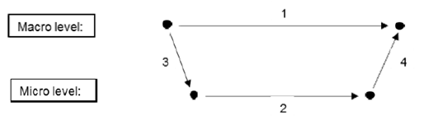
Figure 7: Macro-micro-macro model
In this case the municipality of Groningen tries to influence the route decision of the cyclist to change the cycle pressure on the transport network of the city. By influencing micro-level outcomes, the municipality wants to acquire a macro-level outcome in which the cycle pressure on the transport network is evenly distributed. The societal phenomenon of start is the situation in which there a large number of students that have classes at the same place ‘Zernike Campus’ with a big proportion of them using the same mode of transportation namely a bike. The cause of the overload of certain lanes is the fact that most of those cyclists have to be at Zernike at the same time throughout the day. The situational mechanisms are the factors that make up the social situation in which the individuals operate and connect the first macro-to-micro link in the Coleman Boat illustrated in figure 7. Starting and ending classes at somewhat same time can be categorized as the situational mechanisms. The micro-level situation is influenced by the action forming mechanisms that relate to the ways in which individuals reach decisions and connects the micro-to-micro link. These action forming mechanisms include individual preferences, beliefs, and opportunities. In this case cyclists will pursue personal interests and take the route that matches their personal interest the most. Before the project this resulted in many cyclists using Zonnelaan road. Lastly, the transformation mechanism explains how the aggregated behaviour of individuals results in a certain societal outcome and concerns the micro-to-macro link in the figure. Together the aggregated individual actions result in an unintended macro-level outcome, namely an undesirable distribution of the cycle pressure on the transport network that lead to overcrowded bicycle lanes at certain times and places that cause dangerous situations and economic societal costs due to interference with other traffic. By influencing the route choice behaviour of the cyclists, the societal outcome can change. Since cyclists take the route that is the route they perceive as the optimal route, the project needs to advice routes that cyclists perceive to be their new optimal route instead of the one they usually take. The change of the perception of the optimal route needs to be achieved for success of the project. However, during the interviews one respondent, 2-W-F, explicitly stated her distrust in the advised routes and believed the advised routes were not in her interest. Work by JMP (1989) proved that drivers in London did take advised routes to extend their knowledge on the network but tend to ignore it if they suspect the route to be a sub-optimal option. This means that it is important for this project ‘Smart Bicycle Routes’ and similar projects that cyclists need to think the advised routes are a better route for them than the one they usually take.
The Jaagpad turned out to be taken for its green scenery but for some other it was the reason not to take the route especially at night. A research done by Herzog and Kutzli (2002) found that college students at a university in the Midwestern United States perceived a vegetation environmental setting fearful since it gives the students a feeling of being trapped by the vegetation. The comments on the Jaagpad validated this point by showing this fearful aspect with comments describing the route as scary.
The signs on the road did clearly affect the route choice behaviour of at least one subject 1-E-M during his first months in the city as an international student. This subject is an international student and expressed relief and content when seeing the signs that guided him to Zernike Campus. The signs on the road decreased his anxiety and stress since he was new in the city and often got lost. This is in accordance with Adler (2001, 1) claiming that route guidance decreases anxiety and stress associated with travel planning. Road users almost always take the advised routes in unfamiliar areas (Bonsall, 1992). Once the subject got familiar with the area and therefore created a mental map of the network, his reason to take the Jaagpad was not because of the signs anymore, but of his personal preferences for a green scenery and absence of traffic lights. However, this does not mean that road users in familiar areas will never consider new advised routes to their destination. As mentioned before, research by Papinski, Scott, and Doherty show home-to-work commute are not fixed despite the fixed locations. Changes in route choice does occur and can be attributed to factors such as the exploration of a personally better route or minor changes due to convenience. Since drivers are open to explore new routes this can indicate that cyclists can be too.
Lastly, one of respondents, 6-W-F, mentioned the preference for traffic lights on a route. This is quite surprising since this is in contrast with both the results of online survey and interviews performed here and the existing literature on route choice such as the research of Papinski, Scott and Doherty (2009) mentioned earlier. Apparently, the traffic lights made this respondent feel safe. This can suggest for more research on the different perceptions of traffic lights and its impact on route choice behaviour.
In a broader sense more research can be done on the factors making up the personal preferences of route choice and its impact on route choice behaviour. This would be important since this research showed how people can be spread out on the transport network based on their different preferences for route choice. Knowing what factors make up these personal preferences means knowing how to influence the road users within a transport network. This eventually can lead a more successful, efficient, and safe transport network. Additionally, the differences in the decision making process between road users such as cyclists, car drivers, truck drivers etc. can be investigated. Up and till now the factors making up the route choice seemed to be quite similar for cyclists and car drivers but this does not mean that there are no differences. It is also interesting to evaluate the route choice behaviour of different demographic groups.

Conclusion
Evaluation project ‘Smart Bicycle Routes’
The project ‘Smart Bicycle Route’ did result in a more spread-out cycle pressure on the transport network of the city (De Jager, 2017, 45). The results showed that the routes of the ‘Smart Bicycle Routes’ are taken together with the route Zonnelaan, which was exactly the goal of the project. Over the years of 2014-2016, the percentages of the relative use of the routes seem to point at a more evenly spread cycle pressure. The online survey also showed a quite even distribution of cyclists on the smart bicycle routes and the Zonnelaan. As seen in existing literature and this research, travel time is the most important factor. The differences in perceived travel time of the routes were not significant because travel time was valued the highest in route choice and still a quite evenly spread cycle pressure emerged. Travel time is the most important factor but not the only important factor (Bonsall & Parry, 1990). Besides travel time, the motivation for each route choice differed.
The Jaagpad (Smart Bicycle Route west) seemed to be chosen for its greenery, scenery and absence of traffic lights. During the interviews, when people had the chance to explain why they would not take the Jaagpad, the comments showed that the Jaagpad was also perceived as a remote route and therefore unsafe especially during the night.
The Zonnelaan route was mainly taken by the students living in the west of Groningen that gave the highest priority to the minimization of travel time. This route was perceived as the route that takes the least amount of travel time despite the presence of two traffic lights. Additionally, there were comments about the convenience of this route since it passes by a local shopping centre. Lastly, it was also perceived a safer alternative of the Jaagpad at night due to the presence of more buildings and people in a better lighted area.
The route involving Kerklaan and Eikenlaan, ‘Route East’ of the ‘Smart Bicycle Route’, was only popular for the people living in the east of Groningen. The motivation for this route was mainly travel time.
All in all, the intervention of the municipality’s project ‘Smart Bicycle Route’ turned out to be a success. The route choice behaviour of the cyclists did change. People are willing to take advice despite the tendency to keep to their routine and the perceived unreliability of the advice. Additionally, all routes turned out to have different factors that made the route attractive. However, besides the factors mentioned before underlying the motivations for each route, other factors that could influence the decision were almost equal or made equal. For example, the quality of the ground surface does not differ too much between the routes because the municipality improved the route situation on all routes of the ‘Smart Bicycle Route’. Since there are differences in personal preferences of route choice, the cyclists were evened out over the route options to Zernike based on those personal preferences. This means that eventually the combination of the project promoting alternative routes, the project optimizing the routes to minimize other differences, the absence of significant differences of perceived travel time between the routes, known or not, the different characteristics of each route intended or not, made the project successful.
Overall conclusion
Even though people seem hesitant to change routes, they do explore if they suspect the advised route to fit their preferences more than the one they usually take (JMP, 1989). The ‘Smart Bicycle Routes’ did influence the route choice behaviour of cyclists travelling to Zernike despite the fact that the advice could be considered unreliable as seen in the interviews. The answer on the research question turns out to be paradoxical: People are open to explore new routes despite the tendency to keep to their routine. All in all, cyclists can be redirected when they are provided with advised routes especially when they are in an unfamiliar area. However, after getting familiar in the area the cyclists, when provided with different route options, will eventually take the route that matches the most with his or her personal preferences. For an evenly spread amount of cyclists over different route options for the same destination, the routes need to be perceived as having no significant differences in travel time or any other factor that could influence route choice such as surface quality but one significantly different factor for each distinctive route option such as greenery/scenery, convenience such as passing by a shopping centre, most direct route. This way the cyclists will be spread out based on their personal preferences.

References:
Adler, J. L. (2001). Investigating the learning effects of route guidance and traffic advisories on route choice behaviour. Transportation Research Part C: Emerging Technologies, 9(1), 1-14.
Arnott, R., & Small, K. (1994). The economics of traffic congestion. American scientist, 82(5), 446-455.
Bonsall, P. (1992). The influence of route guidance advice on route choice in urban networks. Transportation, 19(1), 1-23.
Bonsall, P. W., & Parry, T. (1990, May). Drivers' requirements for route guidance. In Road Traffic Control, 1990., Third International Conference on (pp. 1-5). IET.
Bovy, P. H., & Stern, E. (2012). Route Choice: Wayfinding in Transport Networks: Wayfinding in Transport Networks (Vol. 9). Springer Science & Business Media.
Coleman, J. S. (1986). Social theory, social research, and a theory of action. American journal of Sociology, 91(6), 1309-1335.
Creswell, J. W. (2013). Research design: Qualitative, quantitative, and mixed methods approaches. Sage publications
De Jager (2017) Slimme Fietsroutes Groningen [Powerpoint Slides]. Available on request.
De Rook (2015) Ruim 3 miljoen euro voor betere Fietsroutes (RTVOOG, Interview) [Audio clip] Retrieved from https://www.youtube.com/watch?v=KdX7dHExKT4 [on 13th November 2017]
Elvik, R. (1994). The external costs of traffic injury: definition, estimation, and possibilities for internalization. Accident Analysis & Prevention, 26(6), 719-732.
Gemeente Groningen (2017a) Afwegegingsnotitie Doortrekken Slimme Routes West (Hoofdstation- Zernike). Groningen, Gemeente Groningen. Retrieved from https://gemeente.groningen.nl/slimmefietsroutewest [accessed on the 13th November 2017]
Gemeente Groningen (2017b) Retrieved from: https://gemeente.groningen.nl/slimmefietsroutewest [accessed on the 13th November 2017]
Golledge, R. G. (1997). Spatial behaviour: A geographic perspective. Guilford Press.
Hanze Hogeschool (2017) Jaarverslag 2016 . Retrieved from: https://www.hanze.nl/nld/organisatie/hanzehogeschool/organisatie-en-bestuur/jaarverslagen/jaarverslagen/jaarverslagen
Herzog, T. R., & Kutzli, G. E. (2002). Preference and perceived danger in field/forest settings. Environment and Behaviour, 34(6), 819-835.
Hunt, J. D., & Abraham, J. E. (2007). Influences on bicycle use. Transportation, 34(4), 453-470.
Jansson, M., Fors, H., Lindgren, T., & Wiström, B. (2013). Perceived personal safety
in relation to urban woodland vegetation–A review. Urban forestry & urban greening, 12(2), 127-133.
JMP Consultants (1989) Study to show the benefits of autoguide in London. TRRL CR 128,TRRL, Crowthorne, UK.
Papinski, D., Scott, D. M., & Doherty, S. T. (2009). Exploring the route choice decision-making process: A comparison of planned and observed routes obtained using person-based GPS. Transportation research part F: traffic psychology and behaviour, 12(4), 347-358.
Rietveld, P., & Daniel, V. (2004). Determinants of bicycle use: do municipal policies matter?. Transportation Research Part A: Policy and Practice, 38(7), 531-550.
Rijksuniversiteit Groningen (2017) Bestuursverslag Rijksuniversiteit Groningen 2016 Retrieved from: http://www.rug.nl/about-us/where-do-we-stand/facts-and-figures/annual-reports/
Schonlau, M., Ronald Jr, D., & Elliott, M. N. (2002). Conducting research surveys via e-mail and the web. Rand Corporation.
Stinson, M., & Bhat, C. (2003). Commuter bicyclist route choice: Analysis using a stated preference survey. Transportation Research Record: Journal of the Transportation Research Board, (1828), 107-115.
Tesch, R. (1990). Qualitative analysis: Analysis types and software tools. London: Falmer.

