Voxel-based analysis of Alzheimer’s Disease and Mild Cognitive Impairment using ¹⁸F-FDG- and ¹¹C-PiB PET

University of Groningen
Faculty of University College Groningen
Major Health and Life Sciences

Name: Theodora van Elk
Student number: S2793857
E-mail: t.van.elk@student.rug.nl

Supervisor:
Drs. F.E. Reesink (Neurology, UMCG)

Co-supervisors:
Prof. Dr. R. Boellaard
Prof. Dr. P. P. De Deyn
Dr. D. Vállez García

UCG supervisor:
Dr E.C. de Haas

Introduction
The elderly population increases and worldwide prevalence of dementia is expected to expand nearly triple to approximately 132 million by 2050 (1) with 9.9 million new patients each year. It may already be among the most costly diseases for society, worldwide, with the current estimate from the World Alzheimer Report being US $818 billion (1) an this is expected to increase in the coming years. Dementia is a broad term for brain diseases that cause a progressive and often gradual decrease in cognitive functioning (2). Cognitive decline is greater than one would expect from the normal effect of aging. The most common form of dementia is Alzheimer’s disease (AD), which makes up 50% to 70% of cases. AD affects approximately 35 million individuals worldwide.
Alzheimer’s Disease is a progressive neurodegenerative disorder that is characterized by the accumulation of extracellular amyloid plaques and intracellular neurofibrillary tangles (3). The amyloid hypothesis points to the accumulation of amyloid-beta peptides either by overproduction or reduced clearance of the amyloid beta peptide as the central event triggering neuron degeneration (4). These amyloid-beta peptides are produced by what is called the amyloidogenic pathway in which the transmembrane protein amyloid precursor protein (APP) is cleaved by secretase beta and secretase gamma into hydrophobic amyloid-beta peptides. These peptides in turn aggregate due to their hydrophobic nature and are thus present in the cerebrospinal fluid (CSF) in decreased amounts as they are sequestered in plaques (5). It is assumed that the aggregation of these amyloid-beta peptides induces synaptic dysfunction and synaptic loss. Consequently, this leads to the inhibition of certain enzymes and a decrease in the utilization of glucose, causing neuronal cell death and cognitive decline (6). The amyloid hypothesis presumes that tau accumulation is an effect of neurodegeneration. Tau is a highly soluble microtubule-associated protein, which is mainly concentrated in axons and stabilizes the microtubule structure. In AD, tau is hyperphosphorylated and unable to interact with microtubules, which causes aggregation into neurofibrillary tangles and disrupts axonal flow (7). CSF phosphorylated-tau (p-tau) correlates to the amount of neurofibrillary tangles found in the brain and thus total-tau (t-tau) is also increased (5). Together, amyloid plaque and neurofibrillary tangles cause neurodegeneration that is a neuropathological characteristic for AD.
Patients who develop AD pass through a transitional state, which can be characterized as Mild Cognitive Impairment (MCI). MCI is a brain dysfunction syndrome which does not cause significant interference with daily functioning. In some patients MCI progresses to AD; in other cases, MCI is a more benign condition which may remit, remain stable, or may progress to AD more slowly (8). Specifically, MCI patients with primary memory deficits have a significantly higher likelihood to progress to probable AD, with a conversion rate of 10-15% per year (9). Recently, it has been shown that amyloid deposition occurs years before clinical dementia and is related to disease progression (10). Thus, MCI represents an important research group to determine which patients develop AD, as well as to better understand how AD progresses. With the main advances taking place in the field of AD treatment it is important to commence treatment at the earliest stages (11) so that patients may receive the maximal benefit of possible treatment options.
Diagnosing AD can be a challenging task, especially in younger patients and in early disease stages. As stated by Whitehouse (12), AD can only be definitively diagnosed by biopsy or at autopsy. This is done by looking at the numbers of plaques and tangles that are present in the specific biopsied region of the brain. The person must also have a clinical history that is consistent with dementia.A brain biopsy in an invasive procedure which requires the removal of a small piece of the brain for the diagnosis of abnormalities in the brain. In AD, the brain cortex contains abnormal collections of plaque. Due to its invasive nature, a brain biopsy is linked to risks associated with anesthesia and surgery as well as possible brain injury. Scarring that can be caused by the biopsy can in turn cause seizures. Hence, a different method is desired to diagnose AD with certainty.
In the last 60 years, an evolution of technological advancements in brain metabolism and radiotracer development has occurred (10). These advancements have facilitated the development of the modern cerebral positron emission tomography (PET). Following World War II, safe radioisotopes were developed bringing PET imaging one step closer to fruition. In 1976, the radiotracer 2-deoxy-2-[¹⁸F]fluoro-D-glucose (¹⁸F-FDG) was first synthesized. This compound is one of the most widely used radiotracers today for neuroimaging and cancer diagnosis.
¹⁸F-FDG is a marker for the tissue uptake of glucose, which closely correlates with tissue metabolism (13). ¹⁸F-FDG cannot be metabolized by the cell, thus cannot be moved out of the cell before radioactive decay. As a result, the distribution of ¹⁸F-FDG is a good reflection of the distribution of glucose uptake by cells in the body. Loss of neurons may result in decreased glucose consumption in distinct brain regions. Areas affected with amyloid beta plaque will most likely show altered glucose uptake compared to healthy controls (14). In AD patients, ¹⁸F-FDG findings reflect a pattern of reduced glucose uptake in temporoparietal association areas, including the precuneus and the posterior cingulate gyrus (15). More recently, advances in the early and differential diagnosis of AD include the use of ¹¹C-Pittsburgh compound B (¹¹C-PiB) which preferentially binds to extracellular amyloid plaques. ¹¹C-PiB is a radiotracer, which can be used in PET scans to image extracellular amyloid-beta plaques in neuronal tissue (16) as it preferentially targets and binds to fibrillar amyloid beta forms found in dense core plaques (17). In AD, ¹¹C-PiB uptake is significantly higher in the frontal and parietal cortices as well as the posterior cingulate than control subjects (18). In a meta-analysis performed by Zhang et al. (19) it was found that ¹⁸F-FDG has a sensitivity of 78.7% and 74.0% specificity. ¹¹C-PiB on the other hand, has a sensitivity of 93.5% and a specificity of 56.2%. Hence, ¹⁸F-FDG may be used to be able to distinguish between dementias as it is not specific for AD. While amyloid imaging sensitive to AD, it is not particularly specific, suggesting that ¹¹C-PiB could also be a marker for other neurodegenerative diseases such as Parkinson’s Disease (20). Therefore, the combination of both PET techniques is a promising option for prediction and diagnosis purposes.
This thesis will focus on the use of ¹⁸F-FDG and ¹¹C-PiB radiotracers in PET imaging and how these methods can help in the diagnosis as well as mapping the disease progression of AD. The main objectives were to understand the pattern of 18F-FDG and 11C-PiB uptake for AD and MCI subjects and the similarities and differences between AD and MCI subjects in ¹⁸F-FDG and ¹¹C-PiB uptake.

Methodology

Study Design
This cross-sectional observational study includes the following groups: 10 patients with MCI, 10 patients with probable AD, and 10 healthy control (HC) subjects. Patients were recruited from the Memory Clinic UMCG. According to the Declaration of Helsinki, all participants gave written informed consent. The ethics committee of the University Medical Center of Groningen approved the experiment.

All subjects underwent a standard dementia screening, including medical history, physical and neurological examinations, standard cognitive test battery, the Mini Mental State Exam (MMSE), screening laboratory tests, cerebrospinal fluid analysis (CSF) and a brain magnetic resonance imaging (MRI) as well as ¹⁸F-FDG and ¹¹C-PiB PET scans. Clinical diagnosis was established by consensus in a multidisciplinary meeting according to clinical criteria.

Inclusion Criteria
All subjects were between 50 and 80 years of age, and every subject must be willing to cooperate and have signed a written informed consent. Normal healthy controls needed an MMSE score between 28 and 30 (30 being the highest possible score) and should not experience subjective memory complaints. MCI subjects needed a diagnosis of MCI (21) which consists of a concern regarding a change in cognition, impairment in one or more cognitive domains, and the preservation of independence in functional abilities. AD subjects needed a diagnosis of probable AD (22) which consists of an impairment of a minimum of two domains, a significant decline from previous levels of cognitive functioning, gradual onset and history of worsening of condition by report or observation, and interference with daily activities and work.

Exclusion Criteria
A subject was excluded from this study if they had a history of major psychiatric illness, medications which could affect outcomes, cerebrovascular disease with cortical infarcts of a Fazekas-score of 2 or higher, pregnancy, and mental incompetence to provide written informed consent. Normal healthy controls must not show abnormal results on neuropsychological tests or suffer from subjective memory complaints. MCI subjects should not have a diagnosis of dementia assessed by clinician and neuropsychologist. The cognitive deficits of AD subjects should not be explained by non-neurodegenerative conditions such as stroke, neoplasm, head injury, hydrocephalus, or other medical condition.

Patient Anonymity
To protect the privacy of each subject participating in this research, each subject was given an anonymous code and personally, identifiable information was removed from the data set. All data was saved in a secure location with limited access.

PET scans: Tracers
All subjects underwent two PET scans on the same day with a PET protocol with ¹¹C-PiB and subsequently ¹⁸F-FDG PET. PET scans were performed using a Siemens Biograph mCT integrated PET/CT scanner in 3-dimensional acquisition mode. Subjects received a venous cannula for tracer injection. All subjects underwent PET scans under standard resting condition with eyes closed. Both ¹⁸F-FDG and ¹¹C-PiB radiotracers were manufactured at the radiopharmacy facility of the nuclear medicine and molecular imaging department of the UMCG and synthesized according to the GMP (Good Manufacturing Procedure) and administered via venous cannula.
The ¹¹C-PiB PET scan was performed for a specific time interval starting at the time of tracer injection of about 400 MBq ¹¹C-PiB. Static scan data was generated by using the PET data of the last 20 minutes of a 60 minute scan (40-60 minutes). The dynamic scan in 3D mode consists of different time frames covering the total scanning time with gradually increasing frame time towards the end of the scan, starting simultaneously with the i.v. injection.
Static 5 min ¹⁸F-FDG PET data was acquired starting 30 minutes after ¹⁸F-FDG injection of 200 MBq and at least 90 minutes after ¹¹C-PiB injection (> 4 times the physical half-life of ¹¹C which is 20 minutes). This timing provides the optimal imaging time point for ¹⁸F-FDG brain PET while minimal residual ¹¹C-PiB activity will be detected due to physical decay.

Visual assessment of ¹¹C-PiB positivity
¹¹C-PiB PET scan images were be visually assessed for increased ¹¹C-PiB signal by a multidisciplinary meeting of medical professionals. As shown in Figure 1, those that show extensive cortical and subcortical uptake of the ¹¹C-PiB tracer are assessed as ¹¹C-PiB positive (¹¹C-PiB+) (23), while those that show minimal or no cortical uptake are ¹¹C-PiB negative (¹¹C-PiB-).
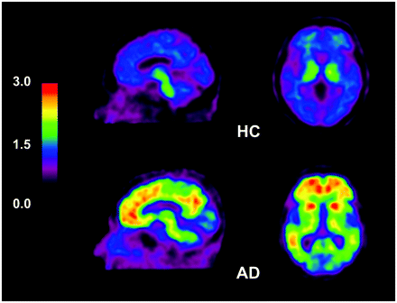
Figure 1 (23): Visual assessment of ¹¹C-PiB uptake - ¹¹C-PiB PET image shows extensive cortical and subcortical uptake in AD subject and is classified and ¹¹C-PiB+(bottom), while the HC subject (top) shows minimal white matter uptake of ¹¹C-PiB and is ¹¹C-PiB-. (red=greatest uptake of ¹¹C-PiB)

Image Processing
Images were processed in PMOD, a software package specifically made to process nuclear scan images (CT, MRI, PET). Each individual PET image was matched with its corresponding individual MRI, using a rigid matching registration procedure. Then, a 3 tissue probability map normalization (24) of the individual MRI into the Montreal Neurological Institute (MNI) standard space was calculated, and later applied to the corresponding PET image. This way the PET images could be moved into ATLAS space, placing all images in a space where the ¹¹C-PiB and ¹⁸F-FDG signal can be compared between patients.
Standardized uptake value ratio (SUVr) images were generated using the static ¹¹C-PiB PET data (40-60 minutes) and ¹⁸F-FDG PET data, considering the cerebellum as reference.

Analysis
Correlations between age, MMSE score, and CSF values were assessed to see if they were confounding factors using bivariate Pearson correlation coefficient with a statistical significance of p<0.05.
The SUV ratio images will be used in Statistical Parametric Mapping (SPM). SPM is a statistical technique for examining differences in brain activity recorded during functional neuroimaging such as PET. The programme uses voxels. Each voxel typically represents the activity of a particular coordinate in three-dimensional space. Voxel-based morphometry registers every brain to a template, which gets rid of most of the large differences in brain anatomy among people. Finally, the image volume is compared across brains at every voxel. Analysis of variance (ANOVA) was used to establish whether there were group differences between AD, MCI, and HC subject groups. If variance is found, two-sample t-tests were performed to determine the variance between HC & AD, HC & MCI, and AD & MCI for both ¹⁸F-FDG and ¹¹C-PiB scans. PET data was also divided into ¹¹C-PiB+ and ¹¹C-PiB- groups, and explored in SPM. For interpretation of the results, T-maps data were interrogated at p=0.001 (uncorrected) and only clusters with p<0.05 corrected for familywise error were considered significant.
In addition, clinical measurements were tested for correlation with PET data by using a multiple regression model. This was done to understand more about the relationship between several independent variables (age, MMSE score, ꞵ-amyloid, t-tau, p-tau) and the PET data.

Results
Subject Group Characteristics
 | AD (n=10) | MCI (n=10) | HC (n=10)
 | Mean (SD) | Mean (SD) | Mean (SD)
age | 66.8 (6.20) | 66.9 (5.47) | 69.1 (3.75)
gender (F:M) | 3:7 | 3:7 | 4:6
MMSE | 24.3 (2.91) | 27.2 (1.81) | 29.1 (1.29)
¹¹C-PiB+ (%) | 0.8 | 0.7 | -
CSF values | (n=8) | (n=8)
ꞵ-amyloid (ng/L) | 481.38 (244.04) | 578.13 (147.71) | -
t-tau (ng/L) | 733.75 (656.68) | 573.13 (302.80) | -
p-tau (ng/L) | 97.13 (61.27) | 86.13 (37.94) | -
Table 1: Patient Group Characteristics - This table shows the average values (Mean) and standard deviations (SD) for age, MMSE score, ꞵ-amyloid, t-tau, and p-tau. Also included is the division of gender and ¹¹C-PiB positivity.

Each subject group consists of 10 patients. The mean age for AD, MCI, and HC are 66.8 (6.20), 66.9 (5.47), and 69.1 (3.75) respectively. Both the AD and MCI group consist of 3 females and 7 males, while HC has 4 females and 6 males. The average MMSE score is 24.3 (2.91) for AD, 27.2 (1.81) for MCI, and 29.1 (1.29) for HC. AD consists of 8 ¹¹C-PiB positive patients and 2 ¹¹C-PiB negative patients, MCI 7 ¹¹C-PiB positive and 3 ¹¹C-PiB negative, while HC consisted of only ¹¹C-PiB negative patients. CSF values were only available for 16 patients, 8 AD and 8 MCI. AD patients showed an average ꞵ-amyloid of 481.38 ng/L (244.04), t-tau was 733.75 ng/L (656.68), and p-tau 97.13 ng/L (61.27). MCI patients showed ꞵ-amyloid, t-tau, and p-tau values of 578.13 ng/L (147.71), 573.13 ng/L (302.80), and 86.13 ng/L (37.94).

The correlation was calculated for age, MMSE, ꞵ-amyloid, t-tau, and p-tau to see how much one variable could explain the variation in another variable.

 |  | Age | MMSE | bAmyloid | Ttau | Ptau
Age | Pearson Correlation | 1
 | Sig. (2-tailed)
MMSE | Pearson Correlation | -0,257 | 1
 | Sig. (2-tailed) | 0,337
ꞵ-amyloid | Pearson Correlation | -0,048 | 0,505* | 1
 | Sig. (2-tailed) | 0,861 | 0,046
t-tau | Pearson Correlation | 0,197 | -0,527* | -0,349 | 1
 | Sig. (2-tailed) | 0,466 | 0,036 | 0,186
p-tau | Pearson Correlation | 0,120 | -0,514* | -0,375 | 0,973* | 1
 | Sig. (2-tailed) | 0,657 | 0,042 | 0,153 | 0,000
Table 2: Correlations between values - In this table the Pearson's correlation coefficient is given for each possible correlation between age, MMSE score, ꞵ-amyloid, t-tau, and p-tau. *shows significant values.

Table 2 shows that there is no correlation between age and other variables. However, there are moderate (0.4-0.6 Pearson's correlation coefficient) correlations between MMSE and multiple variables. MMSE seems to have a positive correlation with ꞵ-amyloid and a negative correlation with t-tau and p-tau. T-tau and p-tau are highly (0.8-1.0 Pearson’s correlation coefficient) correlated with a Pearson Correlation coefficient of 0.973. These correlations are visualized in the Appendix (App. I).

Variance between HC, MCI, and AD for both ¹¹C-PiB and ¹⁸F-FDG

Analysis of Variance (ANOVA) was performed to check whether there is variance between AD, MCI, and HC. Both ¹¹C-PiB and ¹⁸F-FDG scans showed variance between the subject groups, HC, MCI, and AD. This is visualized in Figure 2.

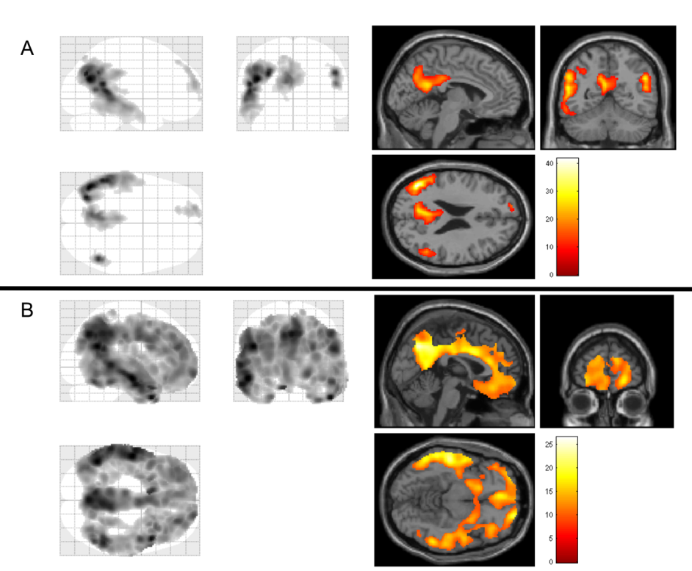
Figure 2: Visualization of ANOVA test. - A: shows the results of the ¹⁸F-FDG. Left shows the Maximum Intensity Projection (MIP) where the gray shows voxel with the greatest variance. Right shows the overlay of the results on a standard MRI image. The red-to-yellow scale indicates the level of statistical significance of the differences in ¹⁸F-FDG uptake. (yellow=most significant difference) B: shows the results of the ¹¹C-PiB scans. Left shows the MIP where the gray shows the voxel with the greatest variance. Right shows the overlay of the results on a standard MRI image. The red-to-yellow scale indicates the level of statistical differences in ¹¹C-PiB uptake. (yellow=most significant difference)

Figure 2A shows that variance is present for ¹⁸F-FDG uptake between AD, MCI, and HC. This variance is greatest in the left temporal lobe, cuneus, and frontal lobe. Figure 2B shows variance between the three groups in ¹¹C-PiB uptake. The areas that vary in the ¹¹C-PiB ANOVA are bilaterally the temporal, parietal, and frontal lobes, as well as the cuneus and precuneus. As ANOVA analysis is unable to explain which of the groups is responsible for the variance two sample t-tests were performed to compare the ¹¹C-PiB and ¹⁸F-FDG scans between groups to understand more about the variance.

AD shows significant decrease in glucose metabolism

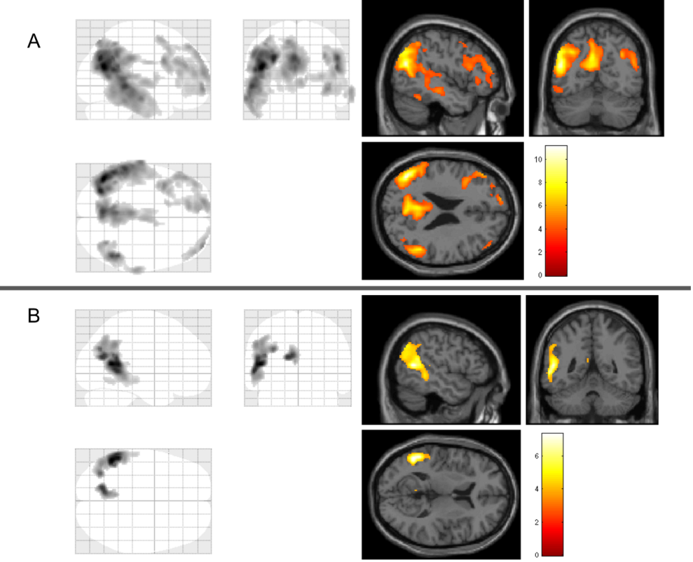
Figure 3: Visualization of ¹⁸F-FDG comparisons. - A: HC versus AD. Left: the MIP shows the voxels (gray) where AD subjects show a significant decrease in ¹⁸F-FDG uptake. Right: the overlay of the results on a standard MRI image. The red-to-yellow scale indicates the level of statistical significance of the differences in ¹⁸F-FDG uptake. (yellow=most significant difference) B: MCI versus AD. Left: the MIP shows the voxels (gray) where AD subjects show a significant decrease in ¹⁸F-FDG. Right: the overlay of the results on a standard MRI image. The red-to-yellow scale indicates the level of statistical differences in ¹⁸F-FDG uptake. (yellow=most significant difference)

HC versus MCI
No statistically significant difference was found in ¹⁸F-FDG signal between HC and MCI patients. Thus, MCI and HC patients showed no statistically significant difference in glucose metabolism.

HC versus AD
When comparing HC and AD patients, AD patients show a decrease in ¹⁸F-FDG signal, and hence a hypometabolism of glucose, as compared with HC subjects (Fig. 3A). This hypometabolism was mainly present in the temporal, parietal and frontal lobes and also other structures such as the frontal gyrus, cuneus, and thalamus. A full list of regions affected with a decrease in ¹⁸F-FDG signal can be found in the Appendix (App. IIA).

MCI versus AD
AD patients showed a decrease in ¹⁸F-FDG signal when compared to MCI patients. Therefore, AD shows hypometabolism of glucose when compared to both HC and MCI patients. The areas of importance are the temporal and parietal lobe as well as the cuneus, all on the left side (Fig. 3B). A full list of regions can be found in the Appendix (App IIB).

MCI and AD subjects show an increase in amyloid deposition

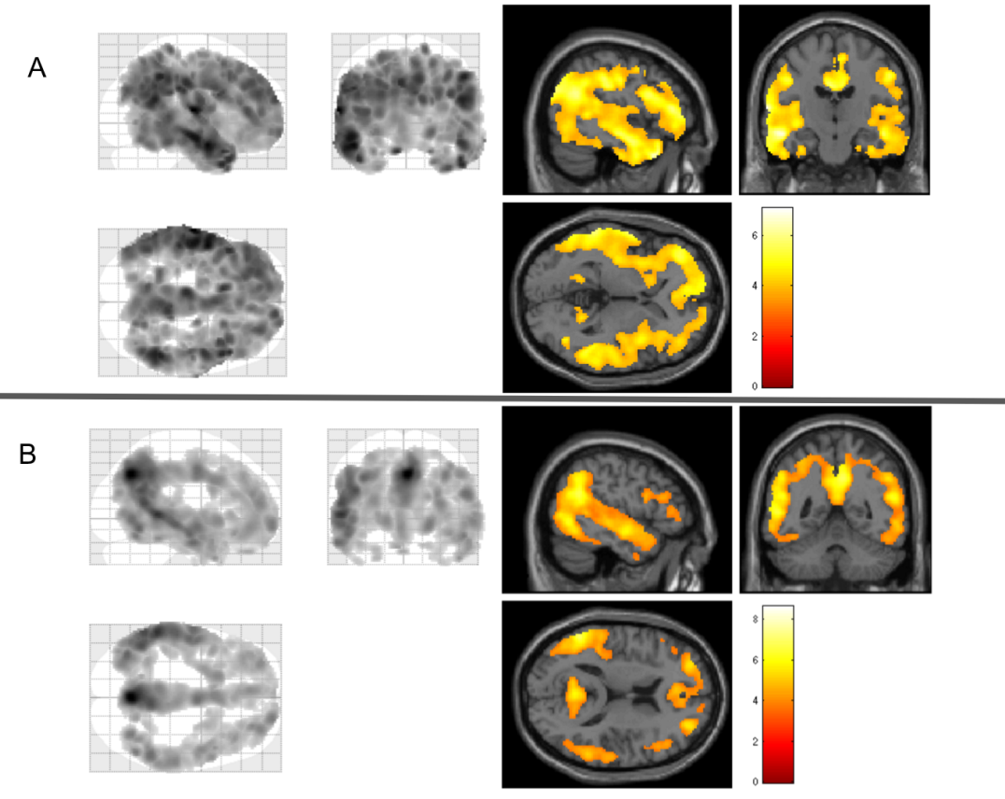
Figure 4: Visualization of ¹¹C-PiB comparisons. - A: HC versus MCI. Left: the MIP shows the voxels (gray) where MCI subjects show a significant increase in ¹¹C-PiB uptake. Right: the overlay of the results on a standard MRI image. The red-to-yellow scale indicates the level of statistical significance of the differences in ¹¹C-PiB uptake. (yellow=most significant difference) B: HC versus AD. Left: the MIP shows the voxels (gray) where AD subjects show a significant increase in ¹¹C-PiB. Right: the overlay of the results on a standard MRI image. The red-to-yellow scale indicates the level of statistical differences in ¹¹C-PiB uptake. (yellow=most significant difference)

HC versus MCI
MCI patients showed an increase in ¹¹C-PiB signal when compared to HC. Thus, MCI patients have increased amyloid deposition. The images show bilateral deposition with the most affected regions in MCI patients being the frontal, temporal, and parietal lobes, as well as structures such as frontal and cingulate gyrus, cuneus, putamen, and insula (Fig. 4A). The complete list of regions can be found in the Appendix (App. IIC).

HC versus AD
AD patients show an increased ¹¹C-PiB signal when compared to the HC group. Therefore, AD patients have increased amyloid deposition. Amyloid deposition is characteristic for AD thus increased amyloid deposition in AD patients is to be expected. The regions that are affected the most are the frontal, temporal, and parietal lobes, including structures such as the frontal and cingulate gyrus, putamen, and cuneus (Fig. 4B). A list of the regions affected can be found in the Appendix (App. IID).
MCI versus AD
No statistically significant variance was found between MCI and AD. Thus, MCI and AD subjects showed no statistically significant difference in amyloid deposition.

¹¹C-PiB+ show a decrease in glucose metabolism and an increase in amyloid deposition
The subjects were also divided into groups based on their ¹¹C-PiB positivity based on their visual assessment. Both groups consisted of 15 subjects. The ¹¹C-PiB positive (¹¹C-PiB+) group consists of 8 AD and 7 MCI, while the ¹¹C-PiB negative (¹¹C-PiB-) group consists of 2 AD, 3 MCI, and 10 HC.
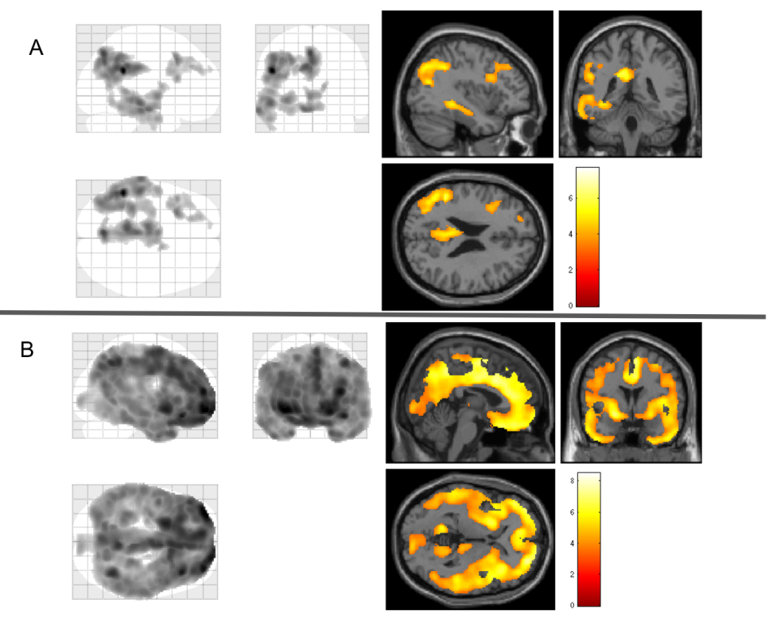
Figure 5: Comparisons between ¹¹C-PiB+ and ¹¹C-PiB- groups. - A: ¹⁸F-FDG. Left: the MIP shows the voxels (gray) where ¹¹C-PiB+ subjects show a significant decrease in ¹⁸F-FDG uptake. Right: the overlay of the results on a standard MRI image. The red-to-yellow scale indicates the level of statistical significance of the differences in ¹⁸F-FDG uptake. (yellow=most significant difference). B: ¹¹C-PiB. Left: the MIP shows the voxels (gray) where ¹¹C-PiB+ subjects show a significant increase in ¹¹C-PiB uptake. Right: the overlay of the results on a standard MRI image. The red-to-yellow scale indicates the level of statistical significance of the differences in ¹¹C-PiB uptake. (yellow=most significant difference)

¹¹C-PiB+ subjects show a significant decrease in glucose metabolism
¹¹C-PiB+ patients showed a decrease in ¹⁸F-FDG signal when compared to ¹¹C-PiB-. Thus, these patients show hypometabolism of glucose. The regions where ¹¹C-PiB+ show a decrease in glucose metabolism are the temporal, parietal, and frontal lobes and structures such as the hippocampus and thalamus. The left side is affected more than the right side as can be seen in figure 5A. The full list of regions with increased ¹⁸F-FDG signal can be found in the Appendix (App. IIE).

¹¹C-PiB+ subjects show a significant increase in amyloid plaque deposition
¹¹C-PiB+ patients showed more ¹¹C-PiB signal and thus have more amyloid plaques compared to ¹¹C-PiB-. This is to be expected as patients were placed in the ¹¹C-PiB+ group because they visually showed ¹¹C-PiB uptake on their ¹¹C-PiB PET scans. The accumulation of amyloid plaques can be seen both left and right in the frontal, temporal, and parietal lobes as well as specific structures such as the cuneus, putamen, thalamus, and insula (Fig. 5B). The complete list of regions can be found in the Appendix (App. IIF).

T-tau and age negatively correlate with ¹⁸F-FDG signal
Multiple regression was performed using age, MMSE, ꞵ-amyloid, and t-tau as variables using the values provided for 16 subjects, 8 AD and 8 MCI. No values for ꞵ-amyloid and t-tau were available because a CSF sample was not taken from HC subjects. Thus, these subjects were excluded from the multiple regression analysis. P-tau was not included as it strongly correlates with t-tau with a Pearson correlation coefficient of 0.973. This test was performed to determine the relationship between variables and the uptake of ¹⁸F-FDG and ¹¹C-PiB.

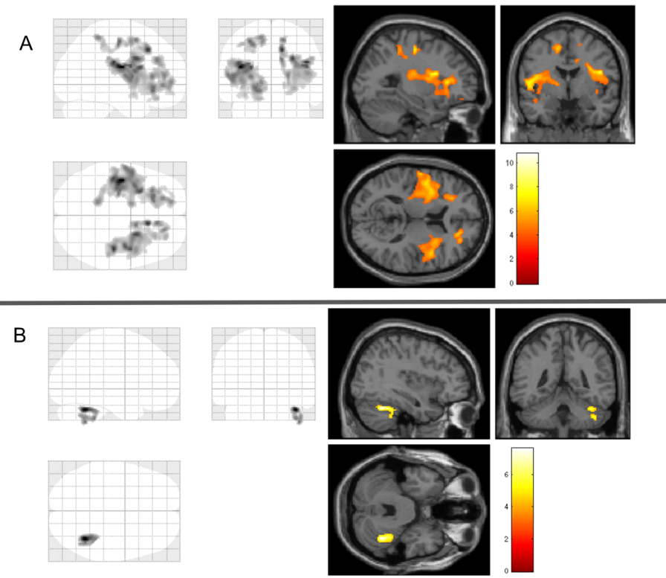
Figure 6: Correlation between ¹⁸F-FDG and t-tau and ¹⁸F-FDG and age. - A: T-tau and ¹⁸F-FDG. Left: the MIP shows the voxels (gray) where a decrease in ¹⁸F-FDG corresponds to an increase in t-tau. Right: the overlay of the results on a standard MRI image. The red-to-yellow scale indicates the level of statistical significance of the differences in ¹⁸F-FDG (yellow=most significant difference) B: Age and ¹⁸F-FDG. Left: the MIP shows the voxels (gray) where a decrease in ¹⁸F-FDG corresponds to an increase in age of subjects. Right: the overlay of the results on a standard MRI image. The red-to-yellow scale indicates the level of statistical significance of the differences in ¹⁸F-FDG. (yellow=most significant difference)

T-tau (and thus also p-tau) negatively correlates to ¹⁸F-FDG signal in frontal and parietal gyrus (Fig. 6A). Specifically in the frontal, central gyrus, and insula. In the Appendix (App. IIG) a full list can be found with the regions affected. Thus, an increase in t-tau correlates with glucose hypometabolism.
Age negatively correlates to ¹⁸F-FDG signal in the cerebellum (Fig. 6B). An increase in age corresponds to a decrease in glucose metabolism.

Discussion
AD patients showed decreased ¹⁸F-FDG signal and thus also decreased glucose metabolism. As glucose is the main source of energy in the brain it reflects the energy needs of the neuronal systems of the brain. In a study performed by Teune et al. (2010) (25) the most prominent decreases in metabolic activity were found in the angular gyrus and other parieto-temporal regions including precuneus extending to the posterior- and middle cingulate gyrus. Furthermore, decreases were found in the right middle and inferior frontal gyrus. In research done by Herholz et. al (2002) (26), patients with probable AD showed a decline of ¹⁸F-FDG uptake in the posterior cingulate, temporoparietal, and prefrontal association cortex. These regions were also affected in the present research. Thus, the results found in this research project are similar to that found elsewhere.
A statistically significant decrease in ¹⁸F-FDG signal is only seen in AD patients, and not in the MCI group. Thus, this suggests that glucose metabolism is affected later on in disease progression of AD. This could mean that the deposition of amyloid causes the disruption of neuronal systems which leads to neurodegeneration and the decrease in glucose metabolism.
Both MCI and AD showed increases in ¹¹C-PiB signal meaning that both MCI and AD patients have increased amyloid deposition. There was no significant difference found when MCI and AD were compared to each other. This suggests that amyloid deposition is the first step in the disease progression “the amyloid hypothesis” and that the amyloid plaques cause neurodegeneration leading to a decrease in glucose metabolism which is seen in AD patients, but not MCI patients. As amyloid plaques are a central event in the etiology of AD, MCI patients with increased amyloid deposition are at an increased risk of developing AD at a later stage. Something that should be noted is that amyloid plaque can be present in healthy brains. In an article by Jansen et al. (2015) (27) they concluded that a 20- to 30- year interval exists between the first development of amyloid positivity and onset of AD. In studies performed by Ziolko et. al (2006) (28) and Kemppainen et. al (2007) (18) AD subjects showed highly significant retention of ¹¹C-PiB in frontal, parietal, temporal cortices as well as in the cingulate and frontal gyri. This coincides with the regions that showed significant retention in the ¹¹C-PiB comparisons.
¹¹C-PiB+ patients showed a decrease in ¹⁸F-FDG signal, and thus also a decrease in glucose metabolism when compared to ¹¹C-PiB- patients. As postulated above, it is most likely that impaired glucose metabolism occurs later in disease progression and thus ¹¹C-PiB+ patients would show a greater impairment in glucose metabolism than those in the ¹¹C-PiB- group. Which is shown in the results.
¹¹C-PiB+ patients show an increase in ¹¹C-PiB signal and thus an increase in amyloid deposition. This is to be expected as patients were placed in the ¹¹C-PiB+ group because they visually showed ¹¹C-PiB uptake on their ¹¹C-PiB PET scans. Thus, this comparison is a confirmation of the visual assessment.
CSF T-tau negatively correlates with ¹⁸F-FDG signal and both are interpreted as neurodegenerative biomarker. Especially an increase in t-tau (and also p-tau) is associated with a decrease in ¹⁸F-FDG signal in the frontal and parietal gyrus. As shown in the results above, an increase in age is associated with a decrease in glucose metabolism in the cerebellum. Older age is associated with higher prevalence of neurodegeneration and dementia. The cerebellum plays a role in motor control, and may also be involved in some cognitive functions such as attention and language as well as the regulation of fear and pleasure responses. The cerebellum does not initiate movement, but helps in the coordination, precision, and accurate timing of movement. Thus, an increase in age could mean a loss of coordination of motor control.
The brain biopsy, which is used for diagnosis of definite AD is invasive. PET imaging on the other hand is a procedure with no adverse effects for the subjects. The venous cannula which is used for the injection of the radiotracer is minimally invasive and the tracer concentration does not have a pharmacological effect on the subjects. Thus, the use of PET imaging may be preferential for the diagnosing of dementias.
For the ¹¹C-PiB PET scan the subject is placed in the scanner for 60 minutes. This can be uncomfortable for subjects thus a shorter acquisition such as that of ¹⁸F-FDG (30 minutes) would be preferred, however this is could also be less accurate. Therefore, further research is needed to better depict the dynamics of ¹¹C-PiB which could eventually lead to the use of a shorter PET acquisition.
In this research project, 30 patients were included; 10 AD, 10 MCI, and 10 HC. However, these groups are relatively small for conclusive statements. Thus, in future research, the amount of patients participating should be increased to validate the results and strengthen the conclusions. What would also be of interest in future research is a longitudinal study following the MCI patients to research the disease progression to AD or another dementia. Many questions still remain regarding the disease progression of AD, such as the factors that influence whether MCI remains stable, remits, or progresses and the events that play a central role in disease development.

Conclusion
In the present research, MCI patients show a significant increase in amyloid deposition, but no significant difference in glucose metabolism, while AD patients show a significant increase in amyloid deposition as well as a significant decrease in glucose metabolism. Thus, it can be suggested that amyloid plaque deposition starts years before the first symptoms of AD and is therefore the first step in the progression to AD. Decreases in glucose metabolism seem to occur later on in disease progression caused by the neuronal death linked to plaque aggregation. Therefore, ¹¹C-PiB can be used to visualize the presence of amyloid plaque, while ¹⁸F-FDG is able to show the severity of the disease. The use of both ¹⁸F-FDG and ¹¹C-PiB could be a potentially valuable technique in the prediction of progression to AD in patients with MCI, the differential diagnosis of AD, as well as tracking the progress of possible treatment options targetting amyloid plaques.

References
1. Prince MJ. World Alzheimer Report 2015: the global impact of dementia: an analysis of prevalence, incidence, cost and trends. 2015.
2. Burns A, Iliffe S. Alzheimer’s disease. BMJ. 2009 Feb 5;338:b158.
3. Ballard C, Gauthier S, Corbett A, Brayne C, Aarsland D, Jones E. Alzheimer’s disease. Lancet. 2011 Mar 19;377(9770):1019–31.
4. Hardy J, Allsop D. Amyloid deposition as the central event in the aetiology of Alzheimer’s disease. Trends Pharmacol Sci. 1991 Oct;12(10):383–8.
5. Mattsson N, Zetterberg H. Cerebrospinal Fluid Biomarkers in Alzheimer’s Disease and Frontotemporal Dementia. In: Neurodegenerative Diseases. Springer; 2014. p. 131–57.
6. Hashimoto M, Rockenstein E, Crews L, Masliah E. Role of protein aggregation in mitochondrial dysfunction and neurodegeneration in Alzheimer’s and Parkinson's diseases. Neuromolecular Med. 2003;4(1-2):21–36.
7. Götz J, Ittner A, Ittner LM. Tau-targeted treatment strategies in Alzheimer’s disease. Br J Pharmacol. 2012 Mar;165(5):1246–59.
8. Jack CR, Petersen RC, Xu YC, O’Brien PC, Smith GE, Ivnik RJ, et al. Prediction of AD with MRI-based hippocampal volume in mild cognitive impairment. Neurology. 1999;52(7):1397–1397.
9. Risacher S, Shannon R, Andrew S, John W, Li S, Hiram F, et al. Baseline MRI Predictors of Conversion from MCI to Probable AD in the ADNI Cohort. Curr Alzheimer Res. 2009;6(4):347–61.
10. Portnow LH, Vaillancourt DE, Okun MS. The history of cerebral PET scanning: from physiology to cutting-edge technology. Neurology. 2013 Mar 5;80(10):952–6.
11. Mueller SG, Weiner MW, Thal LJ, Petersen RC, Jack CR, Jagust W, et al. Ways toward an early diagnosis in Alzheimer’s disease: the Alzheimer's Disease Neuroimaging Initiative (ADNI). Alzheimers Dement. 2005 Jul;1(1):55–66.
12. Geldmacher DS, Whitehouse PJ Jr. Differential diagnosis of Alzheimer’s disease. Neurology. 1997 May;48(5 Suppl 6):S2–9.
13. Mosconi L, Berti V, Glodzik L, Pupi A, De Santi S, de Leon MJ. Pre-clinical detection of Alzheimer’s disease using FDG-PET, with or without amyloid imaging. J Alzheimers Dis. 2010;20(3):843–54.
14. Hoyer S. Abnormalities of glucose metabolism in Alzheimer’s disease. Ann N Y Acad Sci. 1991;640:53–8.
15. Bozzali M, Serra L. Biomarkers for Alzheimer’s Disease and Frontotemporal Lobar Degeneration: Imaging. In: Neurodegenerative Diseases. Springer; 2014. p. 159–78.
16. Klunk WE, Engler H, Nordberg A, Wang Y, Blomqvist G, Holt DP, et al. Imaging brain amyloid in Alzheimer’s disease with Pittsburgh Compound-B. Ann Neurol. 2004 Mar;55(3):306–19.
17. Herholz K, Ebmeier K. Clinical amyloid imaging in Alzheimer’s disease. Lancet Neurol. 2011 Jul;10(7):667–70.
18. Kemppainen NM, Aalto S, Wilson IA, Någren K, Helin S, Brück A, et al. Voxel-based analysis of PET amyloid ligand [11C] PIB uptake in Alzheimer disease. Neurology. 2006;67(9):1575–80.
19. Zhang S, Han D, Tan X, Feng J, Guo Y, Ding Y. Diagnostic accuracy of 18 F-FDG and 11 C-PIB-PET for prediction of short-term conversion to Alzheimer’s disease in subjects with mild cognitive impairment. Int J Clin Pract. 2012 Feb;66(2):185–98.
20. Frey KA, Petrou M. Imaging Amyloidopathy in Parkinson Disease and Parkinsonian Dementia Syndromes. Clin Transl Imaging. 2015 Feb 1;3(1):57–64.
21. Ritchie K, Artero S, Touchon J. Classification criteria for mild cognitive impairment: A population-based validation study. Neurology. 2001;56(1):37–42.
22. McKhann GM, Knopman DS, Chertkow H, Hyman BT, Jack CR Jr, Kawas CH, et al. The diagnosis of dementia due to Alzheimer’s disease: recommendations from the National Institute on Aging-Alzheimer's Association workgroups on diagnostic guidelines for Alzheimer's disease. Alzheimers Dement. 2011 May;7(3):263–9.
23. Ng S, Villemagne VL, Berlangieri S, Lee S-T, Cherk M, Gong SJ, et al. Visual assessment versus quantitative assessment of 11C-PIB PET and 18F-FDG PET for detection of Alzheimer’s disease. J Nucl Med. 2007 Apr;48(4):547–52.
24. Ashburner J, Friston KJ. Unified segmentation. Neuroimage. 2005 Jul 1;26(3):839–51.
25. Teune LK, Bartels AL, de Jong BM, Willemsen ATM, Eshuis SA, de Vries JJ, et al. Typical cerebral metabolic patterns in neurodegenerative brain diseases. Mov Disord. 2010 Oct 30;25(14):2395–404.
26. Herholz K, Salmon E, Perani D, Baron JC, Holthoff V, Frölich L, et al. Discrimination between Alzheimer dementia and controls by automated analysis of multicenter FDG PET. Neuroimage. 2002 Sep;17(1):302–16.
27. Jansen WJ, Ossenkoppele R, Knol DL, Tijms BM, Scheltens P, Verhey FRJ, et al. Prevalence of cerebral amyloid pathology in persons without dementia: a meta-analysis. JAMA. 2015 May 19;313(19):1924–38.
28. Ziolko SK, Weissfeld LA, Klunk WE, Mathis CA, Hoge JA, Lopresti BJ, et al. Evaluation of voxel-based methods for the statistical analysis of PIB PET amyloid imaging studies in Alzheimer’s disease. Neuroimage. 2006 Oct 15;33(1):94–102.

Appendix I
Figure 1: Correlation between ꞵ-amyloid and MMSE score - The graph shows the positive correlation between ꞵ-amyloid and MMSE score. As the MMSE score increases, the ꞵ-amyloid increases as well. In AD patients, who typically have a lower MMSE score, ꞵ-amyloid is usually decreased in the CSF as it is sequestered in plaques.

Figure 2: Correlation between T-tau and MMSE - The graph shows the negative correlation between t-tau and MMSE score. As the MMSE score is increased, t-tau decreases. T-tau is a biomarker for the amount of tau in the CSF. In AD patients, who typically have a lower MMSE, t-tau is increased in CSF as more tau is hyperphosphorylated in AD.

Figure 3: Correlation between P-tau and T-tau - The graph shows the positive correlation between p-tau and t-tau. As t-tau increases, so does p-tau. In AD patients, both p-tau and t-tau are increased due to the hyperphosphorylation of the tau protein.

Appendix II
All tables shown in Appendix II are cut off at 200 voxels and are listed in alphabetical order.

Appendix IIA

Region | Voxels | mean T | std of T
Cingulate gyrus posterior part left | 615 | 5,01 | 0,89
Cingulate gyrus posterior part right | 271 | 4,76 | 0,67
Inferiolateral remainder of parietal lobe left | 2317 | 5,59 | 1,45
Inferiolateral remainder of parietal lobe right | 1031 | 4,76 | 0,99
Inferior frontal gyrus left | 522 | 4,12 | 0,47
Lateral remainder of occipital lobe left | 635 | 5,47 | 1,38
Middle and inferior temporal gyrus left | 1505 | 4,82 | 0,84
Middle and inferior temporal gyrus right | 223 | 4,42 | 0,58
Middle frontal gyrus left | 1270 | 4,20 | 0,51
Middle frontal gyrus right | 460 | 4,22 | 0,51
Posterior temporal lobe left | 2664 | 5,18 | 1,14
Posterior temporal lobe right | 433 | 4,24 | 0,73
Superior frontal gyrus left | 867 | 4,40 | 0,63
Superior parietal gyrus left | 1617 | 5,17 | 1,14
Superior parietal gyrus right | 557 | 4,51 | 0,69
Superior temporal gyrus posterior part left | 564 | 4,23 | 0,45

Appendix IIB

Region | Voxels | mean T | std of T
Posterior temporal lobe left | 1031 | 4,58 | 0,85
Inferiolateral remainder of parietal lobe left | 854 | 4,32 | 0,44
Superior parietal gyrus left | 325 | 4,28 | 0,56

Appendix IIC

Region | Voxels | mean T | std of T
Anterior orbital gyrus left | 325 | 4,10 | 0,39
Anterior orbital gyrus right | 237 | 4,19 | 0,51
Anterior temporal lobe lateral part left | 461 | 4,99 | 0,77
Anterior temporal lobe lateral part right | 519 | 4,64 | 0,54
Anterior temporal lobe medial part left | 510 | 4,01 | 0,26
Anterior temporal lobe medial part right | 376 | 4,24 | 0,48
Cingulate gyrus anterior part left | 1155 | 4,41 | 0,40
Cingulate gyrus anterior part right | 1127 | 4,42 | 0,51
Cingulate gyrus posterior part left | 1125 | 4,59 | 0,57
Cingulate gyrus posterior part right | 1098 | 4,93 | 0,53
Cuneus right | 378 | 4,18 | 0,36
Fusiform gyrus left | 290 | 4,00 | 0,30
Fusiform gyrus right | 347 | 4,11 | 0,30
Inferiolateral remainder of parietal lobe left | 2814 | 4,66 | 0,62
Inferiolateral remainder of parietal lobe right | 2600 | 4,50 | 0,62
Inferior frontal gyrus left | 1548 | 4,43 | 0,56
Inferior frontal gyrus right | 1393 | 4,13 | 0,41
Insula left | 1303 | 4,07 | 0,27
Insula right | 1079 | 4,11 | 0,29
Lateral orbital gyrus left | 245 | 3,97 | 0,31
Lateral orbital gyrus right | 265 | 4,26 | 0,36
Lateral remainder of occipital lobe left | 868 | 4,19 | 0,46
Lateral remainder of occipital lobe right | 990 | 4,06 | 0,32
Medial orbital gyrus left | 528 | 4,11 | 0,28
Medial orbital gyrus right | 214 | 3,92 | 0,20
Middle and inferior temporal gyrus left | 1817 | 4,89 | 0,77
Middle and inferior temporal gyrus right | 1957 | 4,22 | 0,46
Middle frontal gyrus left | 3704 | 4,50 | 0,54
Middle frontal gyrus right | 3326 | 4,32 | 0,43
Postcentral gyrus left | 1311 | 4,33 | 0,58
Postcentral gyrus right | 892 | 4,04 | 0,37
Posterior orbital gyrus left | 318 | 4,00 | 0,28
Posterior orbital gyrus right | 246 | 4,03 | 0,30
Posterior temporal lobe left | 3411 | 4,44 | 0,51
Posterior temporal lobe right | 3246 | 4,28 | 0,51
Precentral gyrus left | 873 | 4,09 | 0,40
Precentral gyrus right | 324 | 4,08 | 0,34
Putamen left | 412 | 3,97 | 0,19
Putamen right | 217 | 3,91 | 0,22
Straight gyrus left | 488 | 4,07 | 0,23
Straight gyrus right | 328 | 3,88 | 0,19
Superior frontal gyrus left | 3973 | 4,43 | 0,44
Superior frontal gyrus right | 3429 | 4,18 | 0,42
Superior parietal gyrus left | 2585 | 4,35 | 0,48
Superior parietal gyrus right | 3176 | 4,50 | 0,51
Superior temporal gyrus anterior part left | 527 | 4,61 | 0,65
Superior temporal gyrus anterior part right | 228 | 3,99 | 0,32
Superior temporal gyrus posterior part left | 1759 | 4,39 | 0,51
Superior temporal gyrus posterior part right | 1402 | 4,10 | 0,42

Appendix IID

Region | Voxels | mean T | std of T
Anterior temporal lobe lateral part left | 218 | 4,28 | 0,36
Anterior temporal lobe lateral part right | 320 | 4,43 | 0,45
Cingulate gyrus anterior part left | 873 | 4,39 | 0,46
Cingulate gyrus anterior part right | 786 | 4,30 | 0,50
Cingulate gyrus posterior part left | 857 | 4,66 | 0,59
Cingulate gyrus posterior part right | 818 | 4,89 | 0,64
Cuneus right | 249 | 4,33 | 0,42
Inferiolateral remainder of parietal lobe left | 2113 | 4,86 | 0,74
Inferiolateral remainder of parietal lobe right | 1530 | 4,28 | 0,51
Inferior frontal gyrus left | 473 | 4,05 | 0,32
Inferior frontal gyrus right | 552 | 3,98 | 0,30
Insula right | 405 | 3,88 | 0,20
Lateral remainder of occipital lobe left | 816 | 4,39 | 0,49
Lateral remainder of occipital lobe right | 444 | 4,09 | 0,41
Medial orbital gyrus left | 356 | 4,18 | 0,30
Middle and inferior temporal gyrus left | 1073 | 4,86 | 0,70
Middle and inferior temporal gyrus right | 1317 | 4,19 | 0,40
Middle frontal gyrus left | 1965 | 4,24 | 0,42
Middle frontal gyrus right | 1872 | 4,24 | 0,47
Posterior temporal lobe left | 2766 | 4,79 | 0,75
Posterior temporal lobe right | 2048 | 4,23 | 0,45
Putamen left | 489 | 4,42 | 0,47
Putamen right | 401 | 4,10 | 0,28
Straight gyrus left | 434 | 4,04 | 0,33
Straight gyrus right | 209 | 4,02 | 0,29
Superior frontal gyrus left | 1609 | 4,06 | 0,37
Superior frontal gyrus right | 932 | 4,04 | 0,35
Superior parietal gyrus left | 2362 | 4,71 | 0,91
Superior parietal gyrus right | 2321 | 4,99 | 1,00
Superior temporal gyrus anterior part left | 448 | 4,32 | 0,37
Superior temporal gyrus anterior part right | 366 | 4,31 | 0,39
Superior temporal gyrus posterior part left | 1575 | 4,62 | 0,57
Superior temporal gyrus posterior part right | 1051 | 4,27 | 0,43

Appendix IIE

Region | Voxels | mean T | std of T
Brainstem | 299 | 4,08 | 0,57
Cingulate gyrus posterior part left | 615 | 4,50 | 0,61
Inferiolateral remainder of parietal lobe left | 2269 | 4,38 | 0,62
Lateral remainder of occipital lobe left | 442 | 4,07 | 0,40
Middle and inferior temporal gyrus left | 1193 | 4,14 | 0,51
Middle frontal gyrus left | 706 | 3,86 | 0,37
Posterior temporal lobe left | 1638 | 4,01 | 0,41
Superior parietal gyrus left | 1011 | 4,19 | 0,60
Superior parietal gyrus right | 215 | 3,91 | 0,43

Appendix IIF

Region | Voxels | mean T | std of T
Anterior orbital gyrus left | 772 | 5,49 | 1,15
Anterior orbital gyrus right | 808 | 5,28 | 1,08
Anterior temporal lobe lateral part left | 370 | 4,82 | 0,65
Anterior temporal lobe lateral part right | 526 | 4,75 | 0,54
Anterior temporal lobe medial part left | 494 | 4,28 | 0,54
Anterior temporal lobe medial part right | 748 | 4,59 | 0,67
Cerebellum left | 222 | 4,12 | 0,52
Cingulate gyrus anterior part left | 1259 | 5,40 | 0,62
Cingulate gyrus anterior part right | 1183 | 5,81 | 0,90
Cingulate gyrus posterior part left | 1167 | 4,83 | 0,58
Cingulate gyrus posterior part right | 1022 | 5,26 | 0,78
Cuneus left | 398 | 4,29 | 0,68
Cuneus right | 735 | 4,41 | 0,68
Fusiform gyrus left | 332 | 4,46 | 0,57
Fusiform gyrus right | 475 | 4,34 | 0,50
Inferiolateral remainder of parietal lobe left | 2943 | 4,50 | 0,62
Inferiolateral remainder of parietal lobe right | 3256 | 4,66 | 0,67
Inferior frontal gyrus left | 2065 | 4,99 | 0,67
Inferior frontal gyrus right | 1949 | 4,69 | 0,66
Insula left | 1192 | 4,49 | 0,69
Insula right | 1435 | 4,64 | 0,67
Lateral orbital gyrus left | 392 | 5,48 | 0,96
Lateral orbital gyrus right | 493 | 5,32 | 0,82
Lateral remainder of occipital lobe left | 1323 | 4,35 | 0,66
Lateral remainder of occipital lobe right | 1208 | 4,08 | 0,42
Lingual gyrus left | 583 | 4,14 | 0,61
Lingual gyrus right | 832 | 4,07 | 0,50
Medial orbital gyrus left | 920 | 5,63 | 0,87
Medial orbital gyrus right | 866 | 5,14 | 0,73
Middle and inferior temporal gyrus left | 1707 | 4,57 | 0,51
Middle and inferior temporal gyrus right | 1969 | 4,51 | 0,63
Middle frontal gyrus left | 3633 | 4,98 | 0,93
Middle frontal gyrus right | 3881 | 4,95 | 0,94
Parahippocampal and ambient gyri left | 246 | 4,16 | 0,49
Postcentral gyrus left | 802 | 3,81 | 0,26
Postcentral gyrus right | 1224 | 4,15 | 0,61
Posterior orbital gyrus left | 741 | 5,47 | 0,83
Posterior orbital gyrus right | 747 | 5,29 | 0,81
Posterior temporal lobe left | 3798 | 4,37 | 0,52
Posterior temporal lobe right | 3907 | 4,23 | 0,57
Precentral gyrus left | 941 | 4,03 | 0,43
Precentral gyrus right | 1091 | 4,34 | 0,68
Putamen left | 689 | 5,41 | 1,12
Putamen right | 623 | 4,78 | 0,61
Straight gyrus left | 571 | 6,09 | 0,72
Straight gyrus right | 635 | 5,59 | 0,73
Superior frontal gyrus left | 3976 | 4,58 | 0,72
Superior frontal gyrus right | 4078 | 4,94 | 0,92
Superior parietal gyrus left | 3544 | 4,68 | 0,69
Superior parietal gyrus right | 3506 | 4,74 | 0,72
Superior temporal gyrus anterior part left | 472 | 4,66 | 0,53
Superior temporal gyrus anterior part right | 387 | 4,81 | 0,50
Superior temporal gyrus posterior part left | 1583 | 4,17 | 0,52
Superior temporal gyrus posterior part right | 1630 | 4,50 | 0,48
Thalamus right | 233 | 4,16 | 0,47

Appendix IIG

Region | Voxels | mean T | std of T
Inferiolateral remainder of parietal lobe left | 316 | 5,13 | 0,95
Inferiolateral remainder of parietal lobe right | 250 | 4,88 | 0,78
Inferior frontal gyrus left | 230 | 4,87 | 0,63
Inferior frontal gyrus right | 208 | 4,60 | 0,44
Insula left | 791 | 4,91 | 0,70
Insula right | 527 | 4,57 | 0,41
Middle frontal gyrus left | 570 | 5,00 | 0,86
Middle frontal gyrus right | 513 | 4,86 | 0,75
Postcentral gyrus left | 544 | 5,47 | 1,21
Postcentral gyrus right | 256 | 4,75 | 0,69
Precentral gyrus left | 432 | 5,48 | 0,83
Precentral gyrus right | 483 | 5,03 | 0,74
Superior frontal gyrus right | 442 | 4,86 | 0,81

