Bengt D.H. Snijders (S2688743)

Running head: The effect of Neogenin on a hematopoietic stem cells capacity to self-renewal, and ability to proliferate.
Bachelor thesis 2017

Supervisor: S.S. Lazare

May 1, 2017

Table of Content:

- Introduction
- Methods
- Results
- Discussion

Introduction
The Netherlands and more countries in the European Union are experiencing an increase in their demographics regarding the age group of 65 and older. This will likely result in an increase of patients with matching chronic diseases. In 2005 the increase of 65-plus citizens was fourteen percent and it is estimated to increase to twenty-one percent by 2025.¹ This ageing population brings with them new challenges to the medical field. Considering that ageing leads to relative new diseases and complications. So, medical issues are being encountered that have never been seen before, and that were considered rare when people were getting no older than 40 years. These new illnesses arise in many cases at the cellular level of an individual. Ageing leads to increases of some cancers such as leukaemia and other hematopoietic cell diseases.² The last decade the focus on ageing concerning its medical and biological aspects has intensified. As a result more is now known regarding this subject, nevertheless many aspects are still unclear and require further research. It has been shown that older individuals have a higher percentage of stem cells within the bone marrow than younger subjects. This sounds like a positive phenomenon for the ageing population. However, these larger stem cell populations can be a sign that the older subjects are compensating for their stem cells lack of differentiation capacity. This is likely leading them to make more stem cells to comply with the demand for differentiated cells. This is the case for both mice and humans.³ It was also found that hematopoietic stem cells (HSCs) numbers increase while at the same time the regenerative potential starts to decrease.² So from these points it can be argued that cells in older individuals are less efficient than the cells of a younger person. There is a loss in the self-renewal ability of HSCs and multipontency has been shown to go down in KLS mouse cells. Multipotency is the ability of cells to produce mature cells of different lineages and to form progenitors, and KLS cells are early forms of HSCs.⁴ Despite the fact that long term repopulating HSCs are mostly quiescent these cells still age likewise compared to the rest of the host.⁴ Cells from young and middle aged cells are rarely in S/G2/M phases this is not the case for the older mice were they are frequently in cycle.⁵ There are many causes of the ageing effects on cells which we are witnessing such as DNA damage accumulation⁶, telomerase shortening², with many linking to the HSC ageing. For example ageing of the immune system (immunosenescence) is found to be linked to the top of the HSC hierarchy. These are just a few of all possible factors which need to be taken into consideration in the research field of ageing biology, also showing that the ageing of HSCs can have multiple implications.² It is important to investigate these complications as new research has led to the belief that some molecular pathways leading to rejuvenation might be activated ², thus actively restoring the health issues. If more knowledge is acquired concerning the origin of ageing diseases, then we might be able to slow down or even cure some of them. Also this information is of high value to ensure that elderly are ageing in a healthy way. Hence, not only to increase the length of life, but most of all the quality of life.

Figure 1 – Overview of the hematopoietic stem and progenitor cells: LT-HSC, ST-HSC and MPP.
Overview haematopoiesis
Common Lymphoid

Common Myeloid
ST-HSC (Low self-renewal capacity)
MPP (No self-renewal capacity)
LT-HSC (high self-renewal capacity)

In this paper the focus is mostly on the HSCs proliferation capacity and the possible linkage to Neogenin receptor expression. These HSCs are the stem cells that will form the blood cellular components (figure 1). Haematopoiesis has only a limited amount of HSCs which can differentiate and create the cells needed in the blood⁷ to maintain homeostasis. In the haematopoietic hierarchy there are different types of cells the Long-term hematopoietic stem cells (LT-HSC), Short-term hematopoietic stem cells (ST-HSC), and multipotent progenitors cells (MPP) as well as more differentiated progenitors and mature blood cells. The ST-HSCs have limited self-renewal potential and the MPP have no self-renewal potential. The LT-HSCs on the other hand are capable of undergoing self-renewal during its whole life span and have a high self-renewal potential. Hence, an important distinction between these cells is in their self-renewal capability, besides the fact that the cells also differ in their proliferative ability and their cell surface markers. However, they do have similar multilineage potential.⁸
HSCs located in humans
In foetuses the HSCs can mostly be found in the liver and umbilical cord.⁹ When we look at adults the HSCs mostly localize in
microenvironments (HSC niches). These niches can be found within the bone marrow of the adult; the actual frequencies of HSCs in bone marrow are very low with just two to five HSCs per 10⁵ cells.² This indicates the importance of those few HSCs that are present in the bone marrow to function properly.

Neogenin
To link ageing with the aforementioned changing activity of haematopoiesis it is important to investigate the factors that have an effect on HSC processes and show changes in their gene regulation when humans get older. This paper will investigate the specific factor Neogenin, which is a receptor that changes its intensity of expression during a human lifetime, as it will show an up-regulation with increased age as mentioned by several papers.^{10,11,12,13,14}
Neogenin has been linked to the development of the central nervous system (CNS) in embryos.¹⁵ This shows that at least with one type of tissue it is important for development and migration. Most of the research has been done in mouse models and it is not yet confirmed that all the functions and expressions are the same in humans. However, it is likely that it will be similar in both organisms. Neogenin can work by activation of two ligands. Firstly, a family of ligands named Netrins (Netrin-1, 2, 3, 4) and secondly the Repulsive Guidance Molecules or RGMs (RGMa, RGMb and RGMc). Netrin is expressed at the CNS where it acts as a repulsive or attractive force during the development. The ligands which are called RGMs have different locations where they perform a function. RGMa is largely restricted to the ventricular zones, RGMb is concentrated in post-mitotic neuronal populations and the function of RGMc is currently still unclear, nevertheless it is known that it is not expressed in the CNS.¹⁵ Netrins are mostly described as the attractive ligands and RGMs as repulsive ligands. Furthermore, bone morphogenetic proteins (BMPs) will be tested in this paper as it was found that RGMs function as co-receptors that are able to enhance the cellular responses to BMP ligands. BMPs are part of the transforming growth factor beta superfamily and are able to use type I and type II threonine kinase receptors and SMAD intracellular signaling pathway enabling to have a regulating function in several biological processes.¹⁶ There is already quite some knowledge acquired about Neogenin’s function in the CNS nevertheless, rather unknown is what Neogenin’s precise effect is on the hematopoietic function concerning proliferation and differentiation. This paper will show that there are some strong indicators that Neogenin has an effect on HSC proliferation and possibly some effect on self-renewal. The data was attained at ERIBA (the European Research Institute for the Biology of Ageing) under the supervision of S. Lazare. For this study the research question is: what is the effect of Neogenin on HSCs capacity to self-renew and ability to proliferate?

Methods
This research comprises three parts with the main intention to investigate whether Neogenin has an effect on proliferation of HSCs (LT-HSCs in this paper), but also partly seeing if there might be some relation between Neogenin expression and self-renewal capacity. Firstly, a small section was dedicated to see if there might be a link between self-renewal capacity and Neogenin expression (#1). For the second part we looked at the effect of Neogenin knockdown on proliferation of LT-HSC cells (#2) and the last part was focused on the proliferative capacity of LT-HSC cells in media with different ligand concentrations. The change in certain Neogenin receptor activating ligands concentrations might cause a change in proliferation (#3). The first small component is done to see to what extent Neogenin expression effects self-renewal in different cell colonies (LT-HSC, ST-HSC and MPP). The second and third part will give an indication whether or not there is a possible relation between activation and/ or expression of Neogenin and the proliferative capacity of LT-HSCs. To measure the significance level chi-squared tests were used with a cut off value of 5%.
#1 - Self-renewal capacity and the expression of Neogenin
For this part three cell types and their Neogenin expression were investigated; namely, LT-HSCs, ST-HSCs and MPP. Some outcomes could indicate a relation between Neogenin and a cells self-renewal capacity. These are for example that either the cell type with the highest or the lowest self-renewal capacity has the highest expression of Neogenin and the other cell types linearly corresponds to this outcome depending on their self-renewal capacity. To obtain these results several theoretical and practical steps need to be fulfilled.

Determining the cell types; Hematopoietic stem cells markers
To see what effect Neogenin knockdown has on proliferation of HSCs we used two types of bone marrow stem cells. These are LT-HSCs which have unlimited self-renewal potential (the surface markers are Lin⁻ , Sca-1⁺, c-kit⁺, CD48⁻ and CD150⁺) and ST-HSCs, they have a limited self-renewal capacity (surface markers: Lin⁻ , Sca-1⁺, c-kit⁺ , CD48⁻ and CD150⁻). Lastly, to see the normal expression of Neogenin in HSCs we used freshly isolated LT-HSC, ST-HSC and also MPPs which are bone marrow cells that have no self-renewal capability (surface markers: Lin⁻ , Sca-1⁺, c-kit⁺, CD48⁺ and CD150⁻). The cells were isolated using fluorescent activated cell sorting.

Isolation of RNA and cDNA transformation
To find out what the expression of Neogenin is in specific cell types we isolated RNA from transfected cells. With the goal to retrieve cDNA (complement DNA). cDNA is DNA that is derived from reverse transcription of mRNA and therefore it does not contain introns or signal sequences that you would normally find in a gene. The cDNA can be analysed in a QPCR machine to test the expression Neogenin. Firstly, RNA must be obtained and this is done by following a standardized protocol: NucleoSpin® RNA XS; DNA, RNA and protein purification. An assessment of the quality and quantity of the isolated RNA is done by using a Bioanalyzer and/ or Nanodrop. When this is done the RNA will be converted into cDNA. The transformation to cDNA is done by using the SuperScriptTM VILOTM cDNA synthesis kit.

QPCR
When the cDNA is obtained there is another check for quality and quantity, but now only by checking with the use of the Nanodrop machine. When this is found to be sufficient it is time to go on to the last step which is the QPCR this is done by using Sybergreen, the Neo1 primer mix (to measure Neogenin expression) and the HPRT primer mix which functions as a control. HPRT is a housekeeping gene coding for the enzyme Hypoxanthine-guanine phosphoribosyltransferase (HGPRT), this gene is ideal as a control as it is a constitutive gene that is needed for the maintenance of basic cellular functioning and hence expressed in all cells.
The QPCR machine follows in real time the polymerase chain reaction. It monitors the amplification of a specific DNA molecule during the PCR (polymerase chain reaction) process. This is done by measuring the fluorescent intensity. A higher fluorescence indicates a larger amount of in this experiment cDNA. As you can see in the example QPCR graph in figure two there are multiple curves of amplification. On the vertical axis it shows the relative fluorescence and on the horizontal axis it show the amount of cycles, every cycle produces cDNA so with every cycle the total amount of cDNA increases. Hence, more cycles will result in more fluorescence. You would prefer the graph to go upward before cycle number 30 as at that point water also can become slightly fluorescent and this might interfere with your measurement.

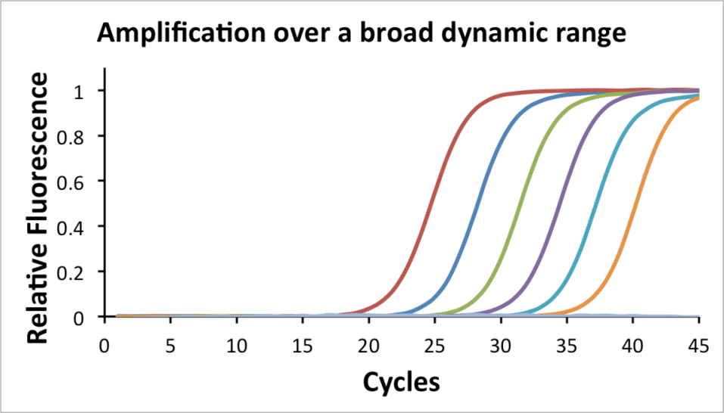
Figure 2 – QPCR example.¹⁷

#2 – Effect of Neogenin knockdown on proliferation
Testing of Neogenin knockdown
As a control of high Neogenin expressing cells and to test the efficiency of ShRNA knockdown we used C212 cells which are myoblasts muscle cells. If we know that these cells express high amounts of Neogenin we can try and perform a Neogenin knockdown (so down regulation) by the use of shRNA constructs. Hence, C212 cells are needed to validate the actual ShRNA knockdown capability. If we can see a clear knockdown of Neogenin in C212 cells, then we can perform a similar knockdown in LT-HSC cells. We can then compare the proliferation outcome to a control by a monoclonal- assay to see whether there is an indication that Neogenin effects the proliferation on LT-HSCs.

Single Cell Assay (monoclonal-assay) with LT-HSCs
The sizes of colonies are scored with the use of a cross in the microscope lens. How much of the cross is covered indicates how many cells there are present in the wells. For example, the smallest category 1 indicates that there is a maximum of about 15 cells present. The cells used were LT-HSCs grown in an expansion media containing: Stemspan, IL-11, Flt3, SCF and FCS (depending on the experiment performed).
Figure 3 – The scoring of colony sizes using the cross in the lens of the microscope, which is divided into 7 categories.
Categories:
- Less than one quarter of one side of the cross: 1-15 cells
- Quarter of one side of the cross: 15-100 cells.
- Half of one side of the cross: 101-1.000 cells.
- Three quarters of one side of the cross: 5.000 cells.
- One side of the cross: 15.000 cells.
- More than 62.5% of the whole cross and smaller 75% of the cross: 30.000 cells.
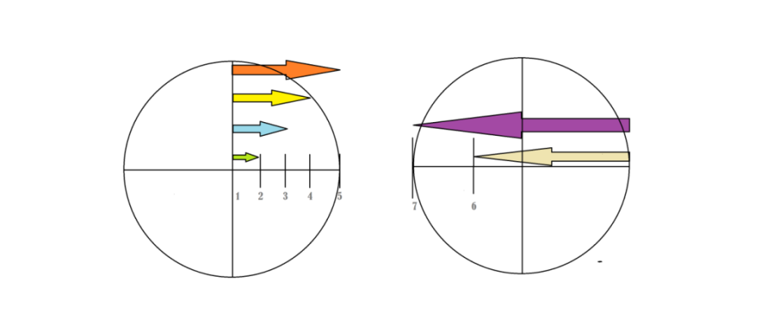
- More than 75% of the cross (the whole cross is filled): 150.000 + cells.

#3 – LT-HSC cells in media with different ligand concentrations
Colonies of LT-HSCs were grown in different plates which had different concentrations of ligands known to activate the Neogenin receptor. So, if more activation of Neogenin leads to higher proliferation then you would expect to see bigger colonies forming when there is more ligand stimulation. The colony scoring was done in the same way as with part #2.

Creating a control medium
To determine the right control medium an extra experiment was done (*3a). In this sub-experiment different substances known for their positive effect on cell culture were tested in different concentrations (FSC, IL-11, Flt-3 and SCF). This was done to obtain a control medium mixture which was able to support proliferation, nevertheless does not over activate the cells. As this would make it difficult to make conclusions on how big the effect of Neogenin activation is on proliferation.

Changing concentrations of Neogenin activating ligands
The last experiment tested different concentrations of Neogenin activation ligands (*3b) and was performed twice, with each eleven plates that have changing ligand concentration. The used ligands were: RGMs (RGMa and RGMb), Netrins (Netrin-1 and Netrin-4) and BMPs (BMP2 and BMP4). The concentrations used ranged from: zero, low (100 ng/ml) medium (250 ng/ml), and high (500 ng/ml) (Figure 4).

Figure 5 – A; Experiment 17.01.2017 B; Experiment 24.01.2017

A.

B.

Results
To understand what effect Neogenin has on proliferation it is important to determine what happens normally at the cellular level. By looking at different types of cell precursors and assessing their expression of Neogenin we get a better understanding in the reason why there is a difference in the expression rate of Neogenin among different cell types. This difference in expression can be influential on the forming of colonies.
In the first experiment it was tested what the expression of Neogenin is in three types of cells, namely the LT-HSC, ST-HSC and MPPs. For this part the emphasis is in seeing whether there seems to be a relation between the cell’s capacity to self-renew and its expression of Neogenin. It can be examined by answering the following questions: LT-HSCs have unlimited self-renewal potential, how much do LT-HSCs express Neogenin?
ST-HSCs have limited self-renewal potential, how much do ST-HSCs express Neogenin?
MPPs have no self-renewal potential, how much does MPPs express Neogenin?

The obtained results indicate that there is at least some sort of relationship between the increased presence of the Neogenin receptor and a cells capacity to perform self-renewal. As presented in figure 5 LT-HSC has the highest expression of Neogenin. Whereas MPP is the lowest Neogenin expressing cell. Coming back to the aforementioned fact that LT-HSC has a higher self-renewal capability than ST-HSC and MPP, it clearly depicts that an increase of Neogenin expression seems to relate to increased self-renewal. Hence, these first results suggest with significance (figure 5c) that cells with a higher expression of Neogenin result in an increase of self-renewal capability.

Figure 5 – A; The relative expression of Neogenin in LT-HSC, ST-HSC and MPP. The graph is set up using a logarithm of the 2^ddCT equation where LT-HSC is set as the point of comparison. B; The relative expression of Neogenin in LT-HSC, ST-HSC and MPP without log. C; Shows the equal variance t-test and unequal variance t-test of ST-HSC and MPP compared to LT-HSC
1

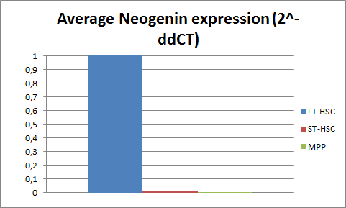
A.

B.
CB.

In the second experiment we looked whether the knockdown of Neogenin has an effect on LT-HSC proliferation. Looking at figure 6 we can see that a knockdown of the gene encoding for the Neogenin receptor seems to result in smaller colonies, so in other words less proliferative activity. A shrink of the colony size was not observed, so it was most likely not caused by cell death. In figure 7 the efficiency of the Neogenin knockdown can be seen, which shows a successful down regulation of the Neogenin encoding gene. Hence, we can say that with a higher Neogenin knockdown there is a lower rate of proliferation. So what this indicates is that there is at least some direct negative effect of decreased expression of Neogenin on the proliferative rate of LT-HSCs.
With the last experiment the focus was on better understanding the possible relationship between Neogenin expression and the proliferation of LT-HSCS. As mentioned in the methods this process was started by finding an optimum control medium (*3a). The plate layout can be found in appendix 1.1 and figure 8 shows the results. From this figure it can be concluded that the 0% FSC has the most moderate proliferation ability with colonies ranging from smallest to largest, with a relative equal distribution with most colonies in the middle sized states.

Figure 6 – A; A stacked chart of the colony scoring assay after 21 days, Neo1-3 and Neo1-4 are two versions of Neogenin knockdown and the SCR serves as a control. Lower scores mean smaller colonies. The x axis shows the scoring in which category the colonies are and the y axis shows the frequency. B; The outcome of the Chi-square test.

 | Chi-square test
Neo1-3 | 3,84073E-07
Neo1-4 | 7,3328E-06

B.

Figure 7 – The expression of Neogenin in the control (SCR) and the knockdown models Neo1-3 and Neo1-4
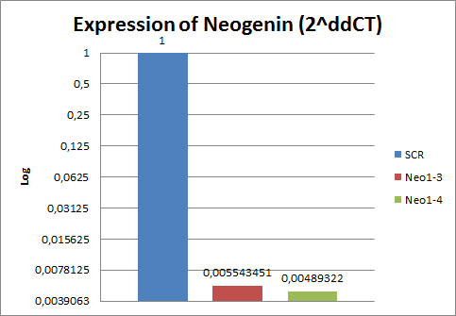

A.

Figure 8 – Outcome of medium optimization experiment 3a. The figure show the proliferation score distribution after 21 days of incubation

Figure 9 – This is an overview after 21 days of the colony scores with different concentrations of various activating ligands. These ligands are: Netrin-1, RGMa, BMP2 and BMP4. The table shows the significance levels using chi-squared. The control medium is the 0% FSC without added ligands (experiment 17.01.17).

Ligands | Chi-squared
Netrin-1 100 ng/ml | 0,008569687
Netrin-1 250 ng/ml | 0,226068179
Netrin-1 500 ng/ml | 0,334662539
RGMa 100 ng/ml | 0,732097749
RGMA 250 ng/ml & BMP2 100 ng/ml | 0,043377767
RGMa 500 ng/ml | 0,10902956
RGMA 250 ng/ml & BMP4 100 ng/ml | 0,000281691
RGMa 250 ng/ml | 0,014331427
BMP2 100 ng/ml | 0,117981704
BMP4 100 ng/ml | 0,003024063

Figure 10 – This is an overview after 21 days of the colony scores with different concentrations of various activating ligands. These ligands are: Netrin-4, RGMb, BMP2 and BMP4. The table shows the significance levels using chi-squared. The control medium is the 0% FSC without added ligands (experiment 24.01.17).

Ligands | Chi-squared
Netrin-4 100 ng/ml | 0,007227999
Netrin-4 250 ng/ml | 0,009667409
Netrin-4 500 ng/ml | 0,06604885
RGMb 100 ng/ml | 0,288388254
RGMb 250 ng/ml & BMP2 100 ng/ml | 0,006857734
RGMb 500 ng/ml | 0,086183737
RGMb 250 ng/ml & BMP4 100 ng/ml | 0,279714201
RGMb 250 ng/ml | 0,012402842
BMP2 100 ng/ml | 2,69103E-07
BMP4 100 ng/ml | 3,97914E-06

The second part of the experiment (*3b) was performed by using the found control medium (0% FSC) and testing various concentrations of Neogenin receptor activating ligands (figure 9). This experiment was done two times with different concentrations of various ligands. The first trial was done with the following ligands: Netrin-1, RGMa, BMP1 and BMP4. For Netrin-1 there seems to be a small increase in the forming of colonies, we can see that there are more colonies in category 7 and less in category 0 compared to the control (with higher levels of Netrin-1). However, except for the lowest concentration (100 ng/ml) with a chi-square outcome of 0,009 there is not a significant difference to the control for the higher concentrations with the values of 0,226 and 0,335. For RGMa there is only significance for the 250 ng/ml concentration, but this plate does not display a conclusive shift towards the higher colony categories. For the two plates with RGMa’s that were combined with BMP2 and BMP4 both resulted in a significant difference to the control (0.043 and 0,000), mostly caused by having les category 0 and more category 3. Nevertheless they do not show a real increase in the highest categories when comparing them to the control. BMP2 on its own did not show any real change compared to the control. BMP4 did show a significant difference (0,003), as it shows an increase in category 3 and a drop in category 0. Interesting is that it is similar to the change which RGMa in combination with BMP4 showed; this seems to suggest that BMP4 is the main source of the shift in colony categories.
The second set of plates comprised out of the following ligands: Netrin-4, RGMb and again BMP2 and BMP4 (figure 10). The Netrin-4 shows significant change almost throughout all the different concentration levels. The highest concentration is just above the significance level of 5% with 0,066, the other values are 0,007 and 0,010. What is contradictory is that it actually seems to show that the higher the concentration of Netrin-4 the lesser the proliferation of the LT-HSCs. RGMb 250 ng/ml is significantly different to the control (0,012) and 500 ng/ml just outside of the significance level (0,086), remarkably both show an increase in category 0 hence less proliferation. RGMb in combination with BMP2 showed an increase in category 7 and was significantly different to the control (0,007), so the combination seems to result in increased proliferation. RGMb with BMP4 did not cause a change in proliferation. BMP2 alone produced a spike in the frequency of category 7 and is proliferating rapidly, also it was significantly different from the control (2,69*10⁻⁷). Lastly, BMP4 was significantly different to the control (3,97*10⁻⁶) and had a reduction in its category 7, suggesting that more cells want to proliferate compared to the control setting.

Discussion
This paper to better understand Neogenin’s effect on proliferation and self-renewal of HSCs has given some new insights. However, there are still quite some points that need further investigation to clarify and verify certain theories. The relationship that was found between the high capacity to self-renew in LT-HSCs and its high expression of Neogenin seems to indicate that there is a link between these characteristics. However, you would need more evidence to really make the claim that it is an important factor. The results only show that there is a significant dropdown of Neogenin with the loss of self-renewal capacity. The strange thing nevertheless is that the LT-HSC, ST-HSC and MPP were all in the same type of medium without the high concentration of Neogenin activating ligands. So, what is triggering the activation of Neogenin is a bit unclear. It might be that the cells start to produce RGM and Netrins by themselves and then it creates a positive feedback loop causing a constant production of ligands. This can be plausible as Neogenin is important in fetal development and should be able to get activated without having a lot of external support. Or it might be that there are still some activating ligands already in the medium that we are unaware of. Therefore it would be wise to do a QPCR on the ligand genes to see whether they might be actively producing these themselves.
Regarding the effect of Neogenin knockdown on LT-HSCs we saw a consistent lowering of proliferation with the lowering of Neogenin expression. Something that was not ideal was the fact that the SCR control cells did not grow into the colonies sizes as expected. They did proliferate significantly more than the Neo1-3 and Neo1-4 knockdown cells. However what you would expect is the SCR to have at least doubled the amount of category 7 colonies then it formed in this experiment. It seems that a lot of cells died so they might have been under too much stress or the SCR shRNA might have done some damage were it should not have. It would be preferred to repeat this experiment to check whether it was just a one-time occurrence or it is something more fundamental and to test if cells were actually dying or not.
For testing the different concentration of substances and to find the optimal medium, were there would be not too much interference in the proliferation. We got a convincing outcome that 0% FSC is the way to go, as it showed the most moderate proliferation rate. It was able to generate colonies of sizes spanning categories 1-7. Moreover, it has the additional added bonus that without the FSC we are more confident that we are not adding extra RGMs and Netrins which might have been in the Calf fetal serum. If there would have been activating ligands in the FSC and we added this serum to the medium we would get a different concentration of ligands different from what we are expecting to measure for. So leaving this out of the “equation” makes the outcome more reliable in that we are working with known concentrations and hence less unknown variables. A small issue arose with finding the right amount of ligands for the medium which was that we initially had two of the same experiments. This to be sure that what we were seeing was indeed correct. However, something went wrong with the second experiment as a lot of the cells were not placed in the wells. Making the number of cells for comparison not enough for any conclusions. Nevertheless, we will use the 0% FSC as the first experiment showed no abnormalities and it also seemed the most logical option. In the experiment with different concentrations of Netrins, RGMs and BMPs it will demonstrate whether it will be able to show a difference in proliferation. If it does not then there are basically two options: 1; Neogenin might have a smaller role in the regulation of HSC proliferation as expected or 2; the current ligand medium is not optimal for finding the proliferation differences for altered concentrations of Neogenin activating ligands. To check whether number two is the case it is wise to do the ligand medium optimisation experiment again and try to find out if a different medium is better.
For the last part where we tested different ligand concentrations; a clear direct link with most ligands which should activate Neogenin increased proliferation was not observed. However, BMPs alone and the combination with BMPs showed a better result. It might be that this is really necessary to get the needed activation of the Neogenin receptor. In the experiment of 24.01.17 it can be seen that BMP2 alone results in better growth then BMP2 combined with an RGM. This is quite contradictory as it is normally understood that BMPs have a positive working on the effects of RGMs. Hence, you would expect a stronger effect in the combined form. As it has been hypothesized that the expression of RGM proteins enables cells to respond to low levels of BMP ligands more selective.¹⁶
Something that seems to come out of the results is that the biggest effect comes from the BMPs with hardly any influence from the RGMs. Something that was strange was that with the 24.01.17 BMP2 caused a very big shift towards the category 7 colonies, nevertheless the exact same plate in experiment 17.01.17 did not show any change whatsoever. It might be that something went wrong when performing the last experiment which caused the strong spike in category 7.
To conclude, Neogenin expression does seem to alter the self-renewal capacity of cells. As LT-HSCs have a higher expression of this gene then ST-HSCs and MPPs. In the knockdown experiment there was a remarkable difference between the proliferation of the cells with and without the Neogenin knockdown. The Neogenin knockdown had much less proliferation. The last experiment did not show conclusively whether the direct activation of Neogenin via the used ligands caused an elevated proliferation rate. However the results of the BMPs do suggest that their activation does cause increased proliferation. It does need to be verified as the BMP duplicated did not give the precise same outcome.

References

1. Blokstra A, Baan CA, Boshuizen HC, Feenstra TL, Hoogenveen RT, Picavet HS, Smit HA, Wijga AH, Verschuren WM. Vergrijzing en toekomstige ziektelast. Prognose chronische ziektenprevalentie 2005-2025. Retrieved from https://rivm.openrepository.com/rivm/handle/10029/16400# on 20-12-2016.
2. Geiger H, De Haan G, Florian MC. The ageing haematopoietic stem cell compartment. Nature Reviews Immunology. 2013 May 1;13(5):376-89.
3. Li T, Zhou ZW, Ju Z, Wang ZQ. DNA damage response in hematopoietic stem cell ageing. Genomics, proteomics & bioinformatics. 2016 Jun 30;14(3):147-54.
4. Roobrouck VD, Ulloa-Montoya F, Verfaillie CM. Self-renewal and differentiation capacity of young and aged stem cells. Experimental cell research. 2008 May 15;314(9):1937-44.
5. Morrison SJ, Wandycz AM, Akashi K, Globerson A, Weissman IL. The aging of hematopoietic stem cells. Nature medicine. 1996 Sep 1;2(9):1011-6.
6. Sharpless NE, DePinho RA. How stem cells age and why this makes us grow old. Nature Reviews Molecular Cell Biology. 2007 Sep 1;8(9):703-13.
7. Lazare SS, Wojtowicz EE, Bystrykh LV, de Haan G. microRNAs in hematopoiesis. Experimental cell research. 2014 Dec 10;329(2):234-8.
8. Forsberg EC, Prohaska SS, Katzman S, Heffner GC, Stuart JM, Weissman IL. Differential expression of novel potential regulators in hematopoietic stem cells. PLoS Genetics. 2005 Sep 2;1(3):e28.
9. Mezey É. On the origin of blood cells–hematopoiesis revisited. Oral diseases. 2016 Feb 1;22(4), 247-248.
10. Rossi DJ, Bryder D, Zahn JM, Ahlenius H, Sonu R, Wagers AJ, Weissman IL. Cell intrinsic alterations underlie hematopoietic stem cell aging. Proceedings of the National Academy of Sciences of the United States of America. 2005 Jun 28;102(26):9194-9.
11. Chambers SM, Shaw CA, Gatza C, Fisk CJ, Donehower LA, Goodell MA. Aging hematopoietic stem cells decline in function and exhibit epigenetic dysregulation. PLoS Biology. 2007 Jul 24;5(8):e201.
12. Noda S, Ichikawa H, Miyoshi H. Hematopoietic stem cell aging is associated with functional decline and delayed cell cycle progression. Biochemical and biophysical research communications. 2009 May 29;383(2):210-5.
13. Wahlestedt M, Norddahl GL, Sten G, Ugale A, Frisk MA, Mattsson R, Deierborg T, Sigvardsson M, Bryder D. An epigenetic component of hematopoietic stem cell aging amenable to reprogramming into a young state. Blood. 2013 May 23;121(21):4257-64.
14. Sun D, Luo M, Jeong M, Rodriguez B, Xia Z, Hannah R, Wang H, Le T, Faull KF, Chen R, Gu H. Epigenomic profiling of young and aged HSCs reveals concerted changes during aging that reinforce self-renewal. Cell stem cell. 2014 May 1;14(5):673-88.

15. De Vries M, Cooper HM. Emerging roles for neogenin and its ligands in CNS development. Journal of neurochemistry. 2008 Aug 1;106(4):1483-92.
16. Wu Q, Sun CC, Lin HY, Babitt JL. Repulsive guidance molecule (RGM) family proteins exhibit differential binding kinetics for bone morphogenetic proteins (BMPs). PLoS One. 2012 Sep 27;7(9):e46307.
17. (n.d.). Specific quantification over a broad dynamic range. My Pols. Retrieved January 11, 2017, from http://www.mypols.de/qpcr-probe-2x-master-mix/.

Appendix
1.1

